***C# Selenium Framework***

***Index:***

1. ***POM (Page Object Model) in C# Selenium***
2. ***Base Class***
3. ***Utilities functions***
4. ***Configuration files***
5. ***Create Testcases***
6. ***Create Test Data & Fetching Excel values to Testcase***
7. ***Sending mail through c# program***
8. ***Extent Reports***

***C# selenium Framework structures and folders***

**Step 1)** Create a new NUnit Project in visual studio

**Step 2)** Right click on Project🡪 Add 🡪 New Solution Folder

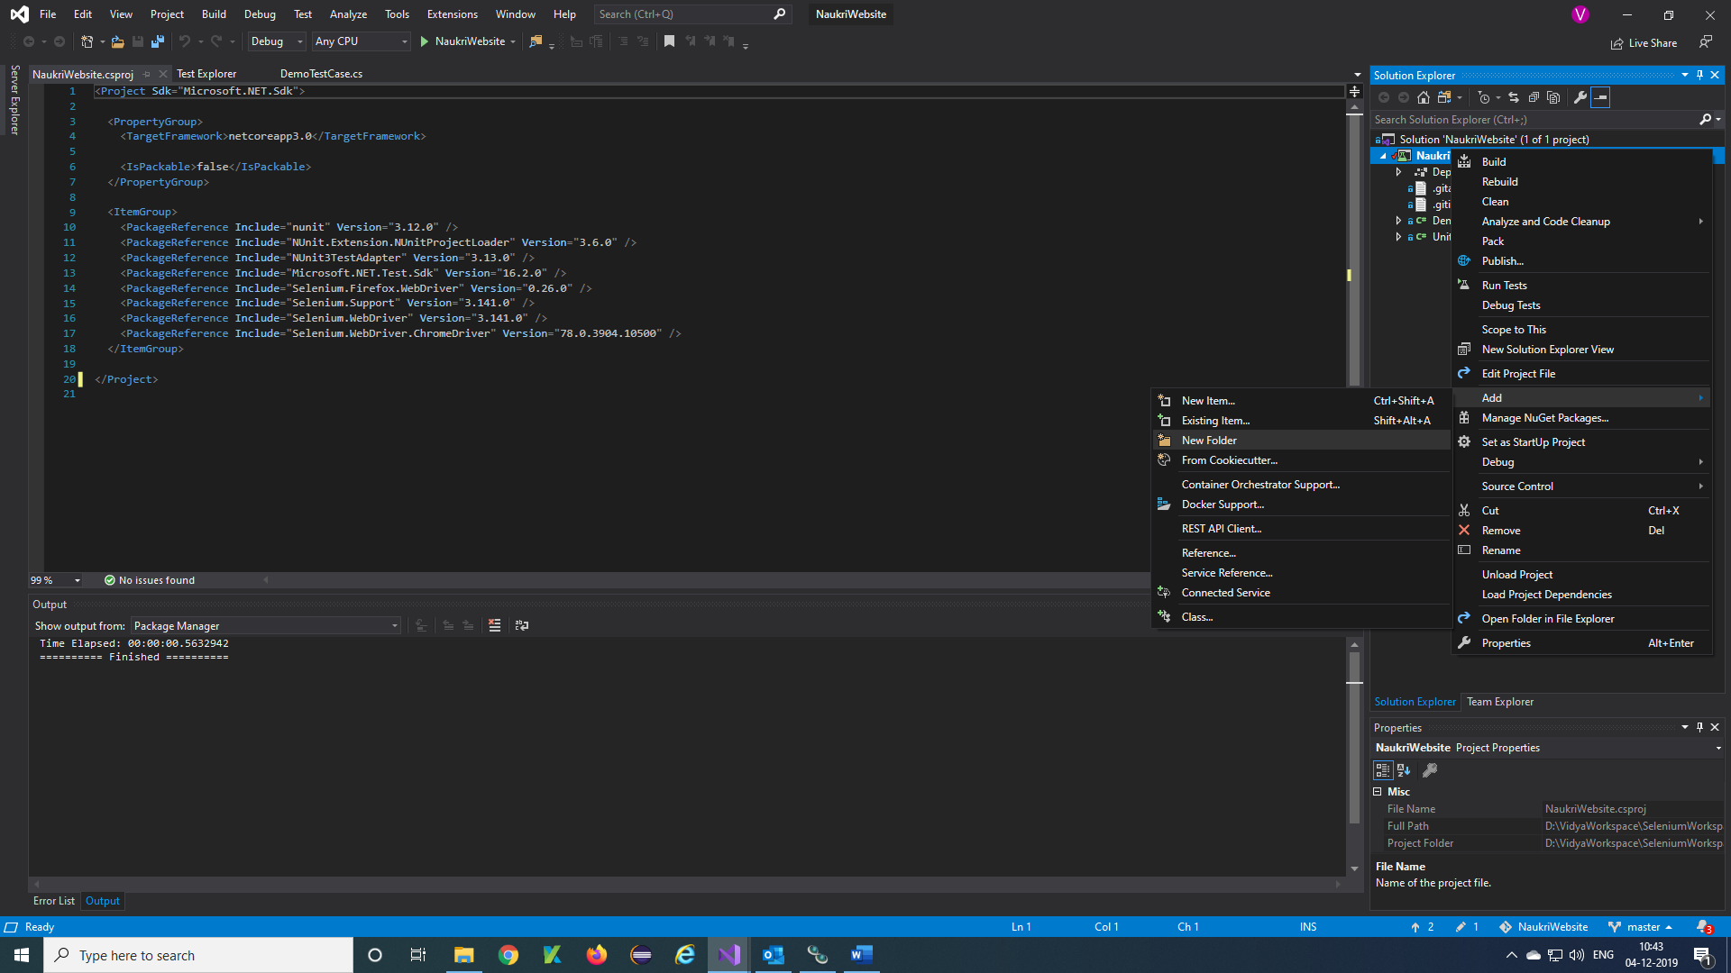

**Step 3)** Give a name for folder 🡪 Enter from keyboard

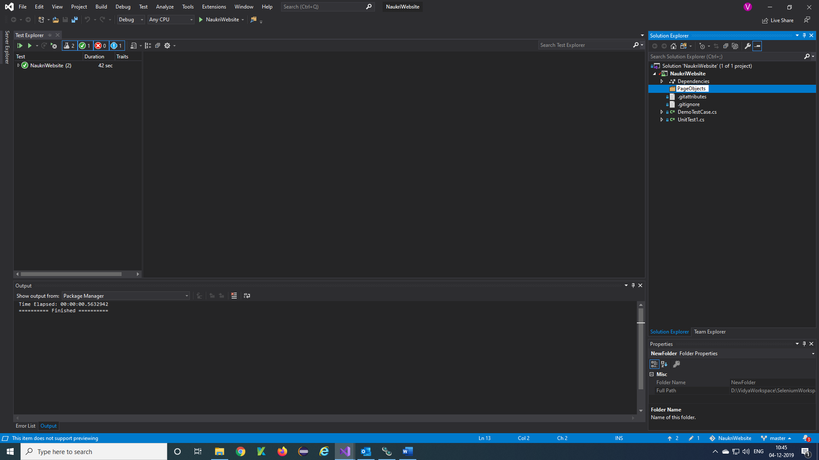

**Step 4)** Right click on Page Objects folder 🡪 Add 🡪 Class

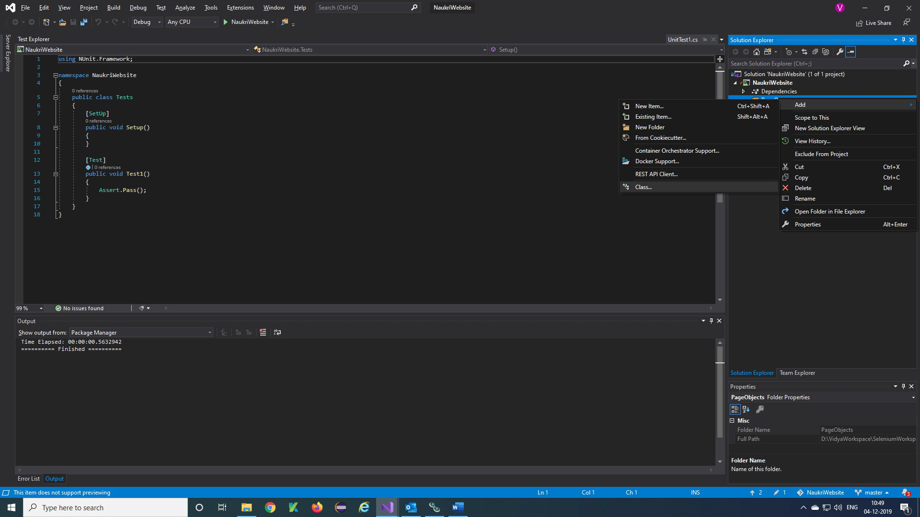

**Step 5)** Give class name 🡪 Add

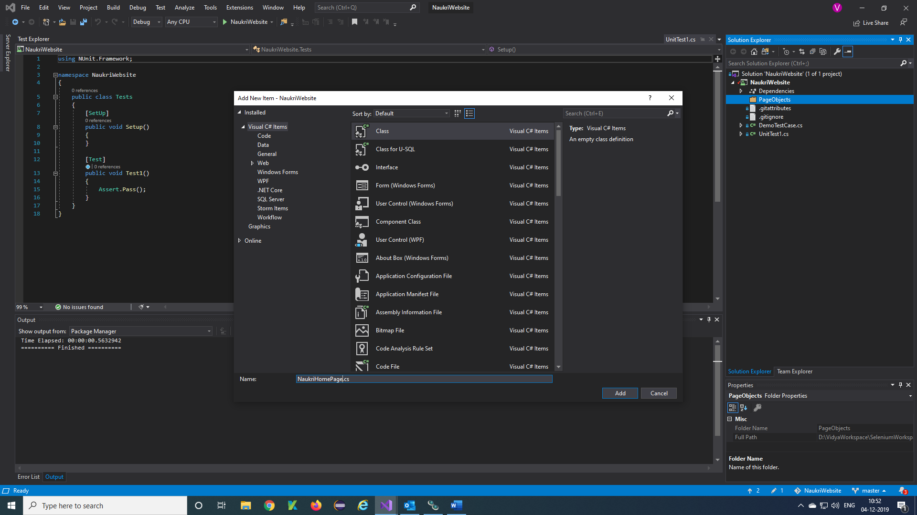

**Step 6)** Created class is added in folder of Page Objects

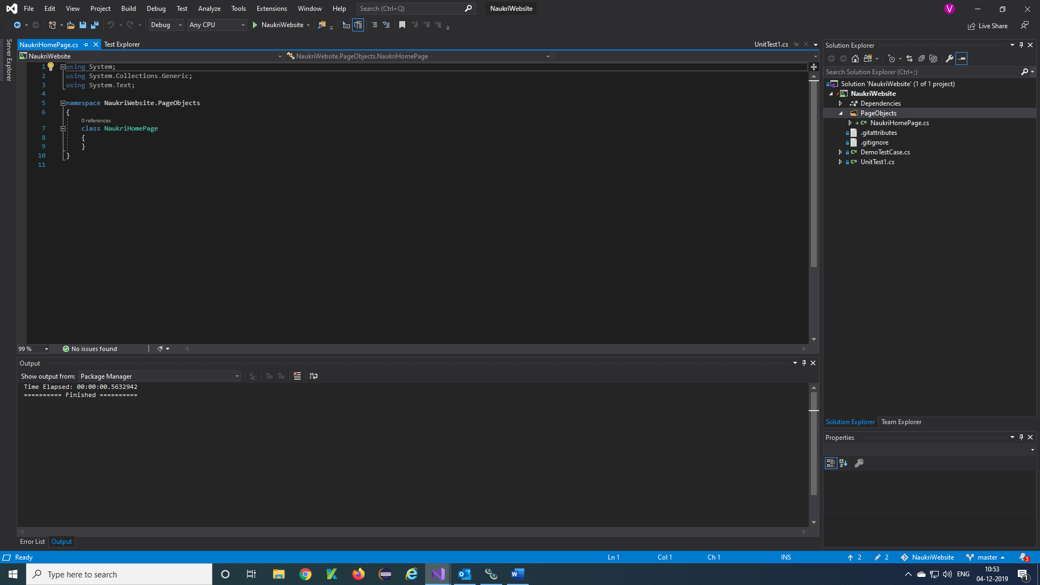

**Note:** You can create required folder structure for your project

***POM in C# Selenium:***

**PageObject Design Pattern:**

The ***PageObject Design Pattern*** models areas of an UI as objects within test code which can also be considered as ***Object Repository*** for *Web UI Elements*. The functionality classes (*PageObjects*) in this design represent a logical relationship between the pages of the application. Each class is referred to as a ***PageObjects***and returns other *PageObjects* to facilitate the flow between pages. Page Object class is responsible to find the WebElements of that page and also hold methods which perform operations on those WebElements.

### **Advantages of using Page Object Pattern:**

* Easy to Maintain
* Easy Readability of scripts
* Reduce or Eliminate duplicacy
* Re-usability of code
* Reliability

**PageFactory in C#**

The ***PageFactory in C#*** Class is an extension to the Page Object Design Pattern. It is an inbuilt POM concept for Selenium WebDriver but it is very optimized. It is used to initialize the elements of the Page Object or instantiate the Page Objects itself. Annotations for elements can also be created (and recommended) as the describing properties may not always be descriptive enough to tell one object from the other.

It is used to ***Initialize Elements*** of a Page class without having to use ‘***FindElement***‘ or ‘***FindElements***‘. Annotations can be used to supply descriptive names of target objects to improve code readability.

### **@FindBy Annotation**

As the name suggest, it helps to ***find*** the elements in the page using ***By*** strategy. ***@FindBy*** can accept **TagName, PartialLinkText, Name, LinkText, Id, Css, ClassName, XPath**as attributes. An alternative mechanism for locating the element or a list of elements. This allows users to quickly and easily create PageObjects.

***[FindsBy(How = How.Id, Using = “username“)]***  
***private IWebElement UserName { get; set; }***

The above code will create a PageObject and name it as UserName by finding it using its ID locator.

**InitElements**

This ***Instantiate an Instance*** of the given class. This method will attempt to instantiate the class given to it, preferably using a constructor which takes a WebDriver instance as its only argument or falling back on a no-arg constructor. An exception will be thrown if the class cannot be instantiated.

***PageFactory.InitElements(WebDriver, PageObject);***  
***Parameters***:

* ***WebDriver*** – The driver that will be used to look up the elements
* ***PageObjects*** – A class which will be initialised

***Returns***: An instantiated instance of the class with WebElement and List<WebElement> fields proxied

**PageFactory NameSpace**

PageFactory functionality resides in ***OpenQA.Selenium.Support.PageObjects.***

**How to Implement PageFactory in Selenium Framework**

**Step 1)**Create a PageObject folder

**Step 2)**Create a class for HomePage of your website

**Step 3)**Write elements and methods for the home page

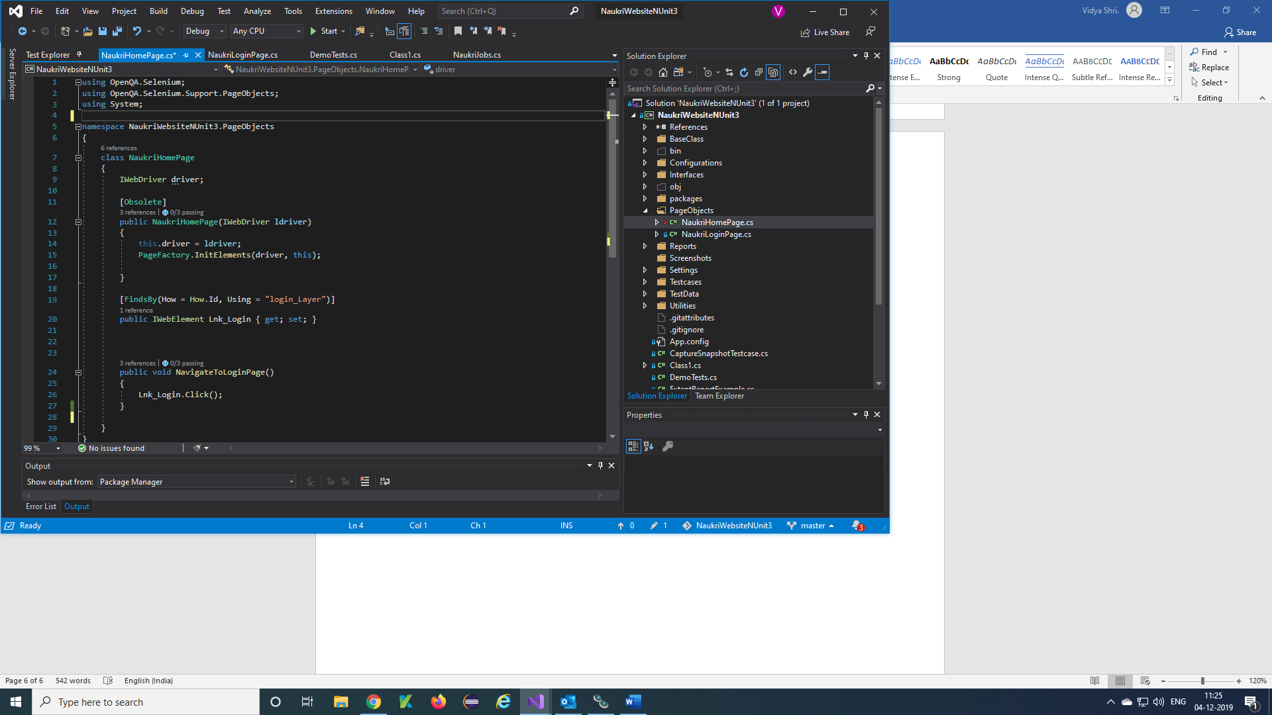

Methods of the pages text here

Elements or Objects text here

**Note:** Like this you can create multiple page classes in page objects folder with elements and methods of the testcases.

***Base class:***

**Step 1)**Create a BaseClass (AppState) folder

**Step 2)**Create a Class for your Base test

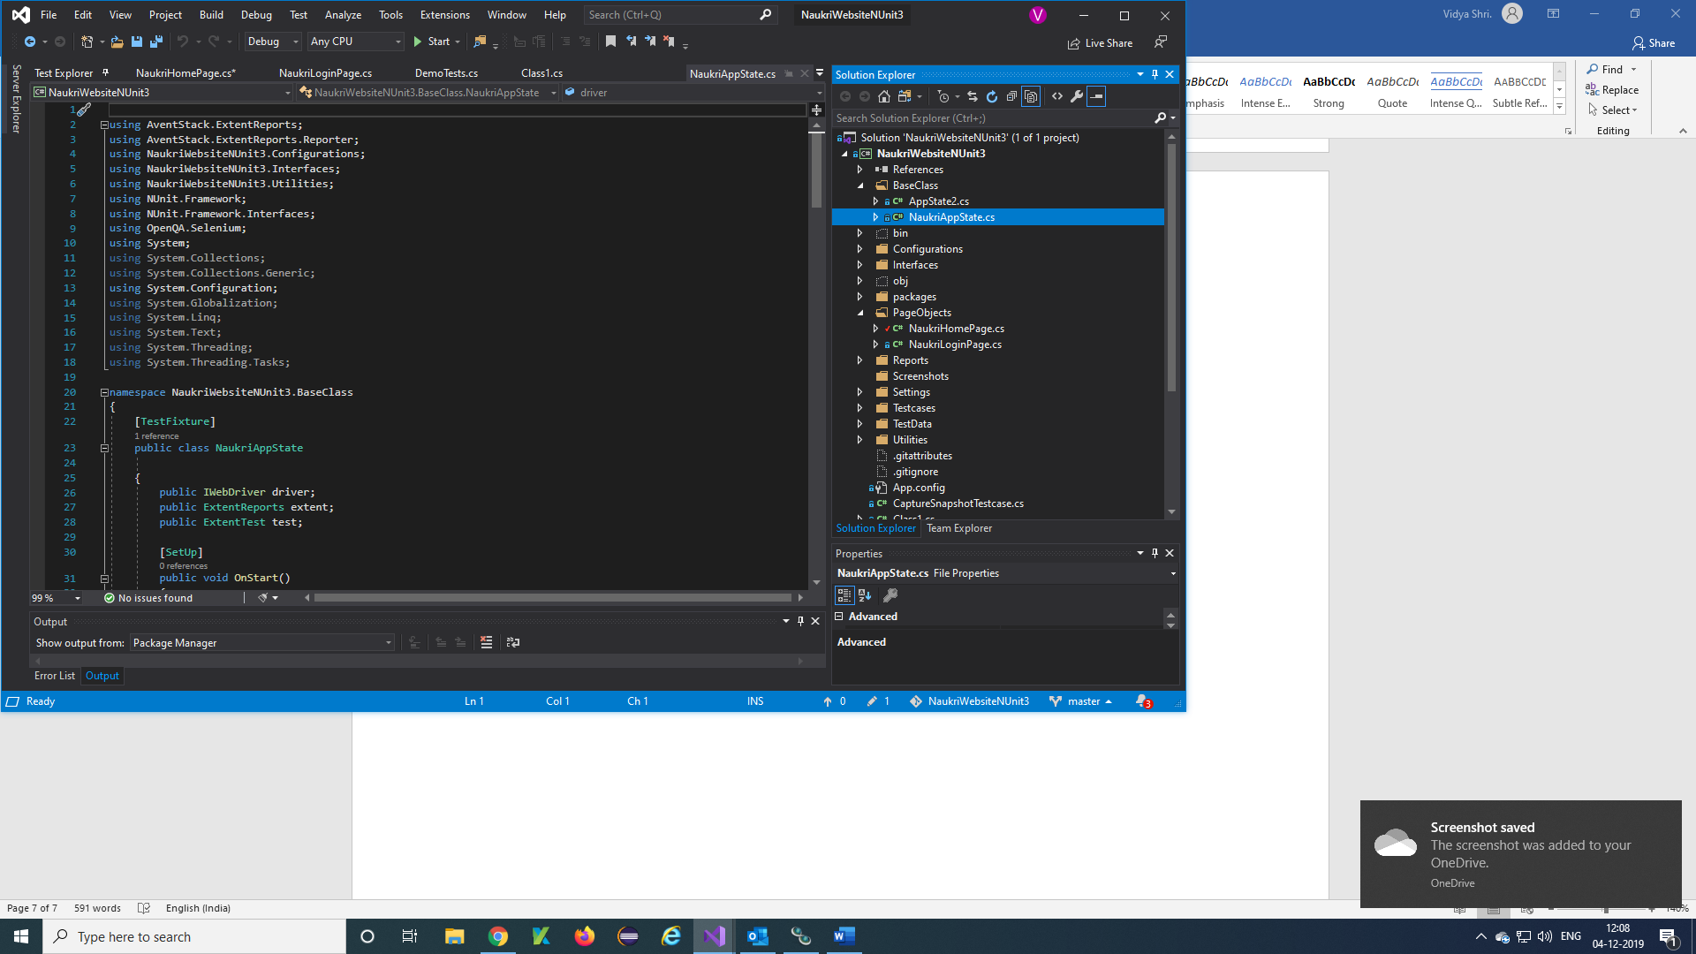

**Step 3)**Write a function using SetUp and TearDown annotations in NUnit framework

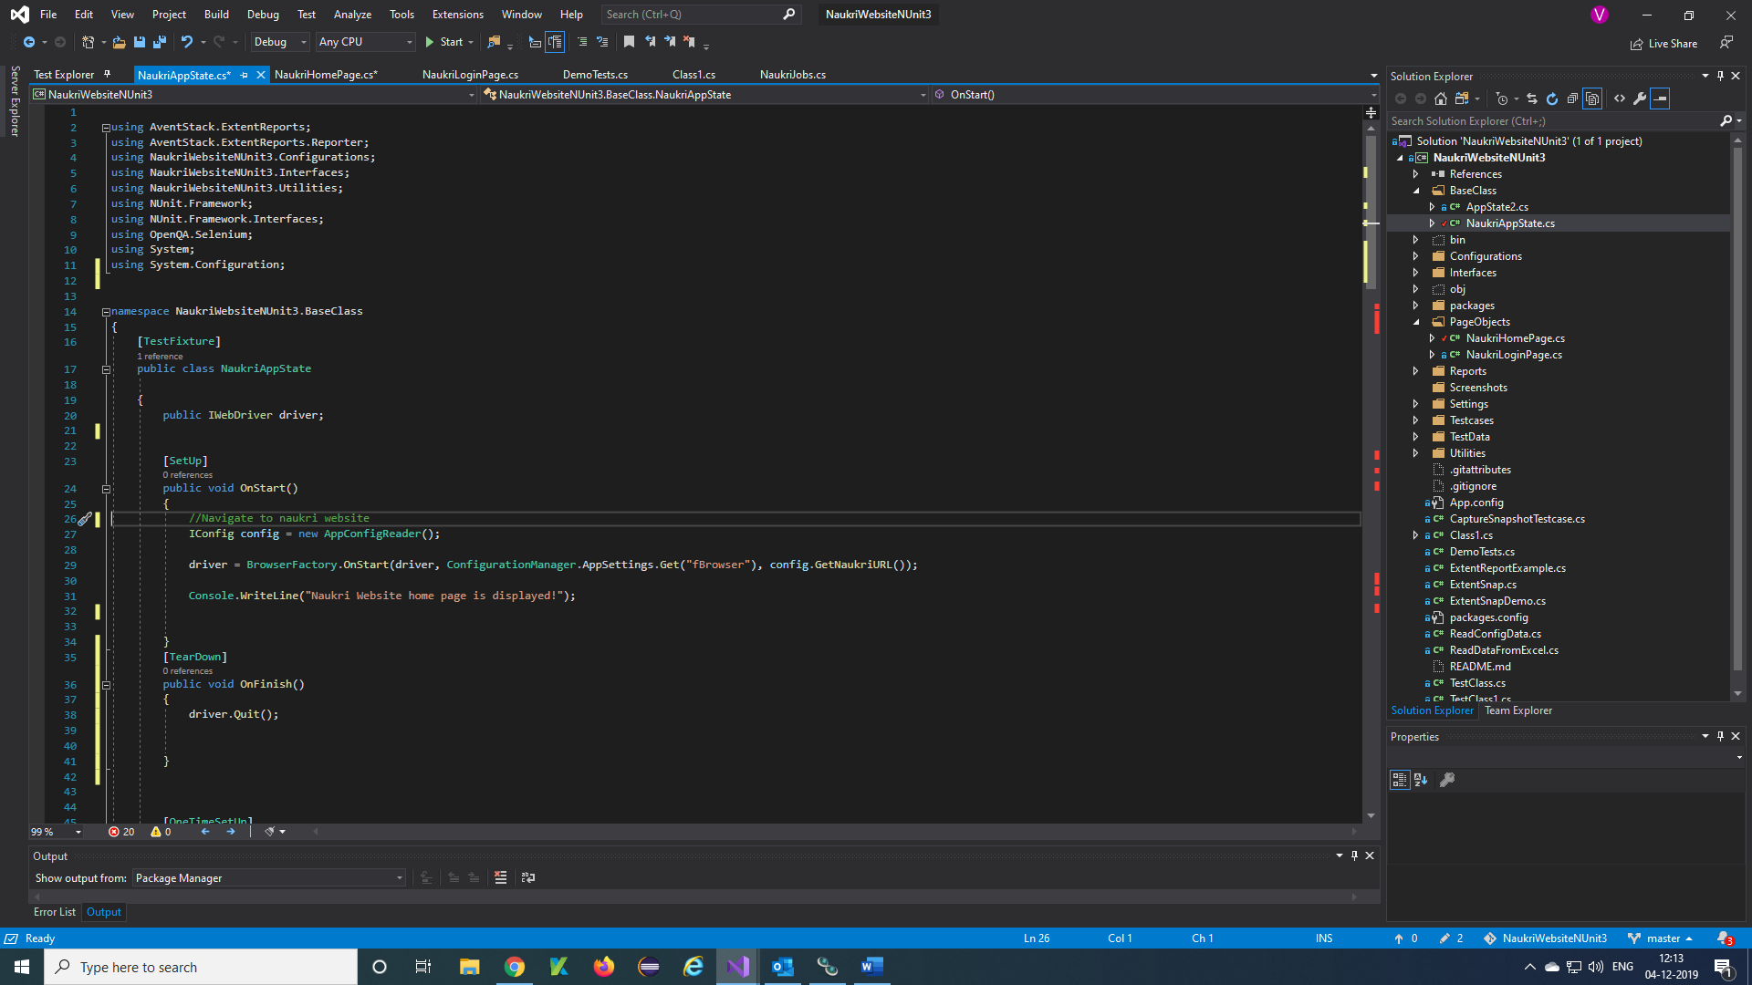

***Utilities Functions:***

**Step 1)**Create a Utilities (AppState) folder

**Step 2)**Create a Class for your Browser Factory

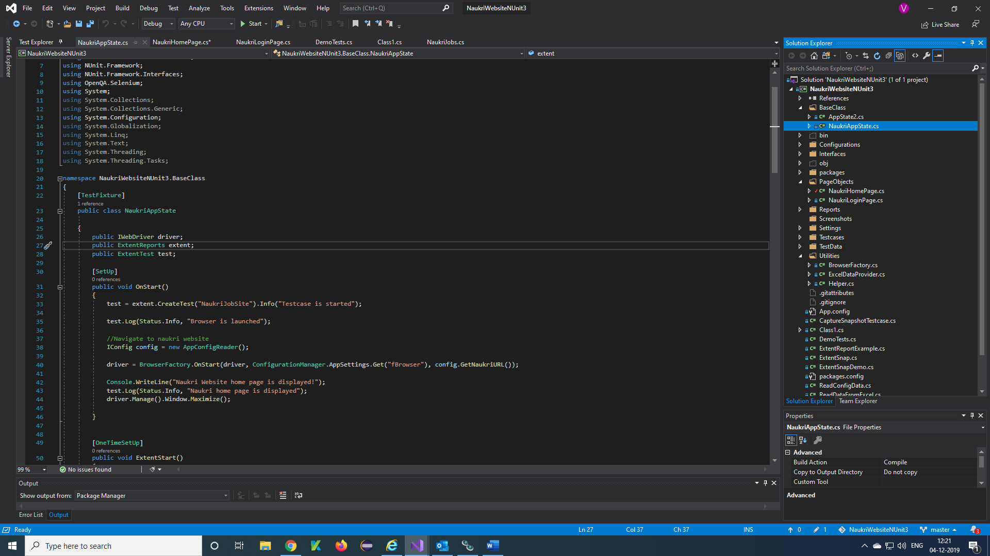

**Step 3)**Write a utility function for browsers

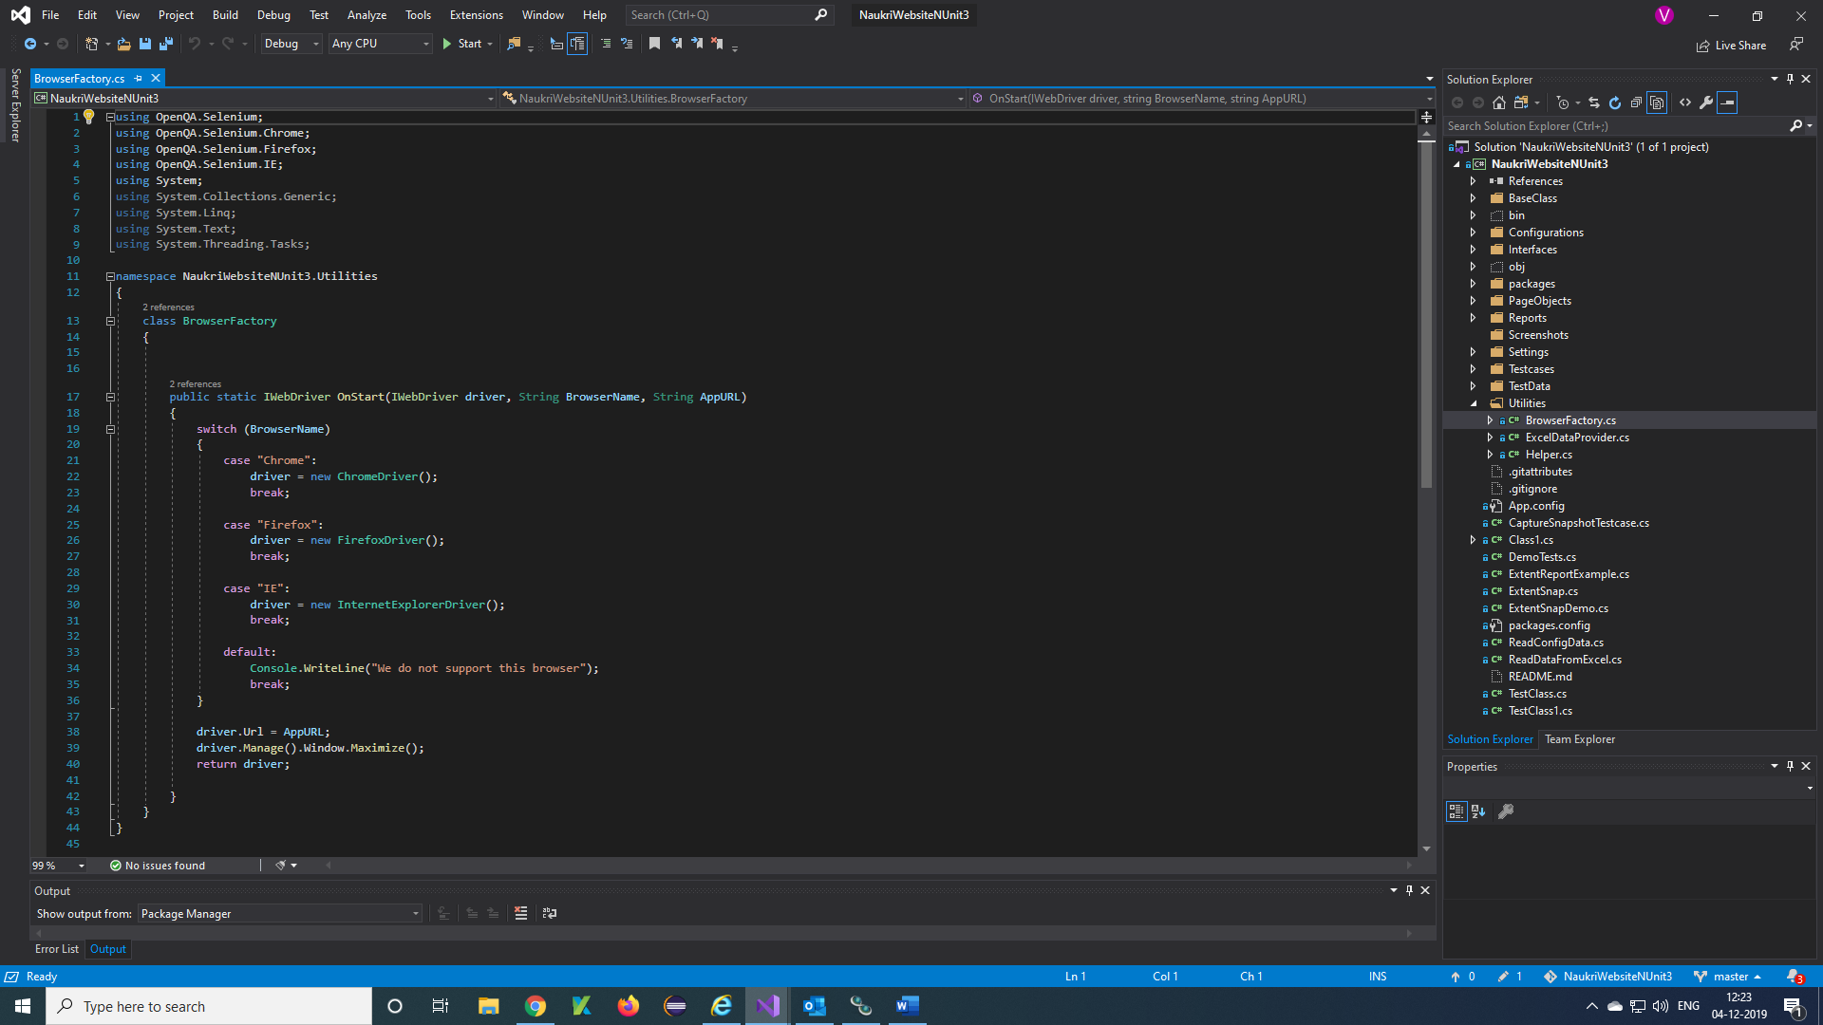

**Note:** You should call Browser Factory function in your base class by creating object of the class

***Configuration files:***

**How to create config file:**

**Step 1)**Right click on Project 🡪 Add 🡪 New Item

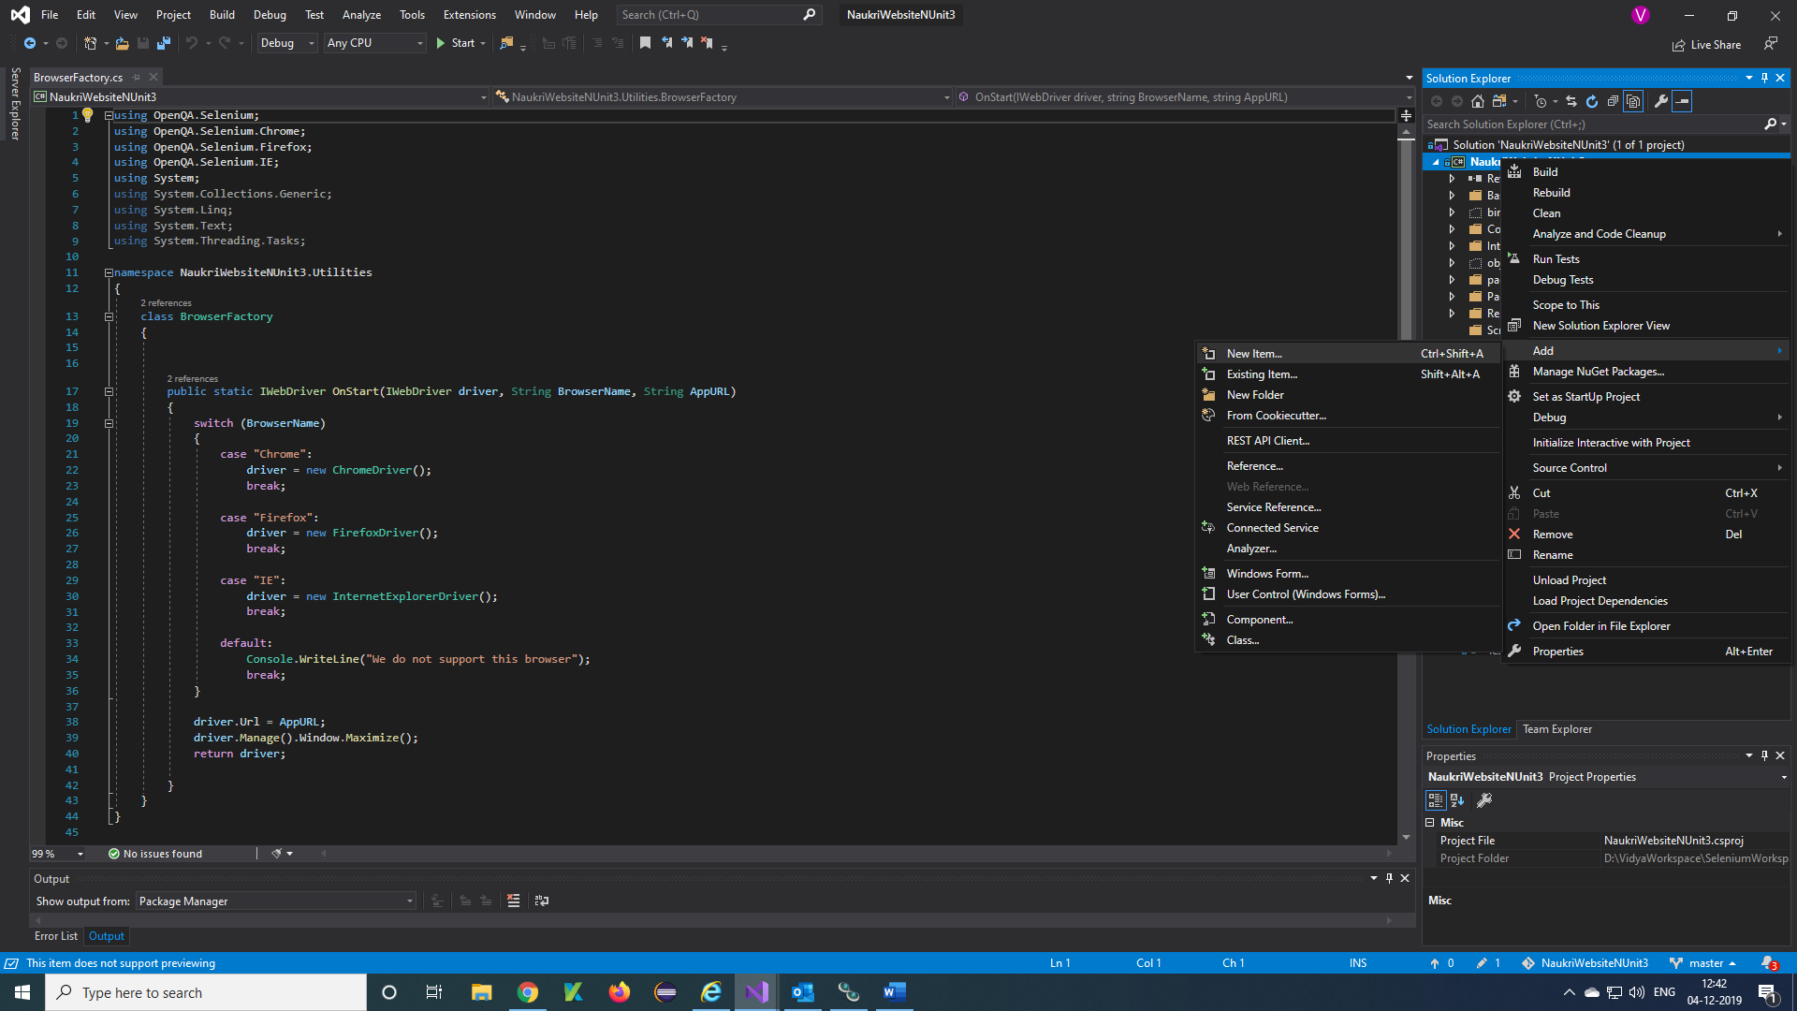

**Step 2)**Enter name App.config 🡪 Add

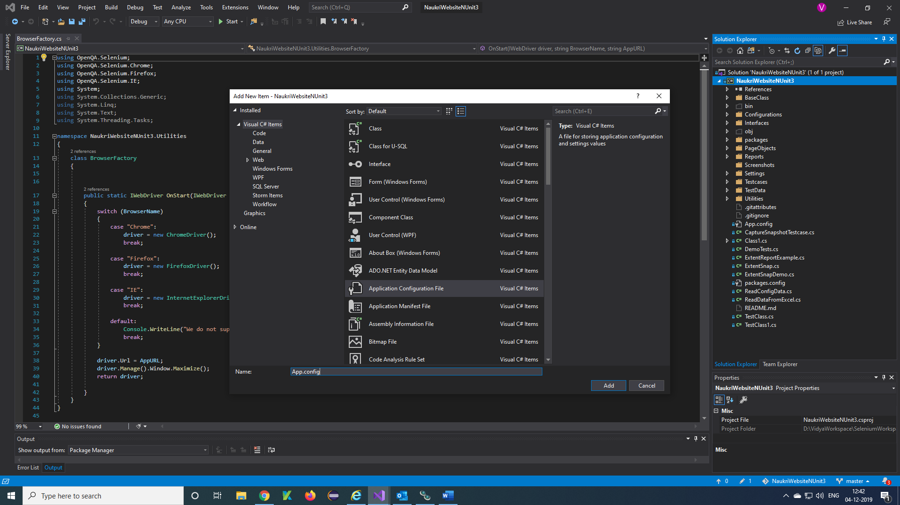

**Step 3)**Write a config data in config file

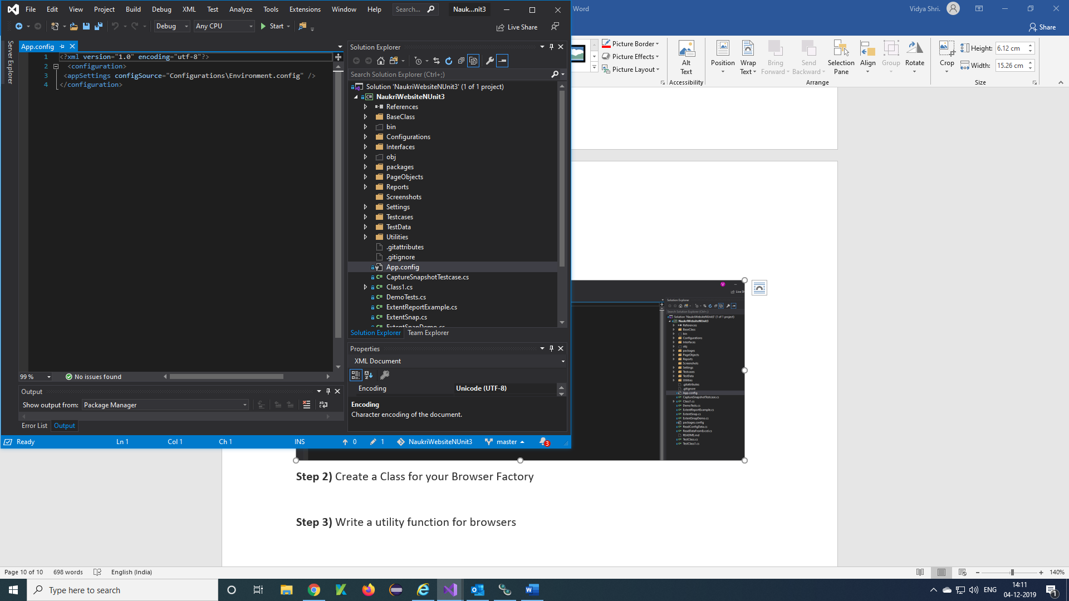

**Create Configurations:**

**Step 1)**Create a Configurations folder

**Step 2)**Create an Environment.config file

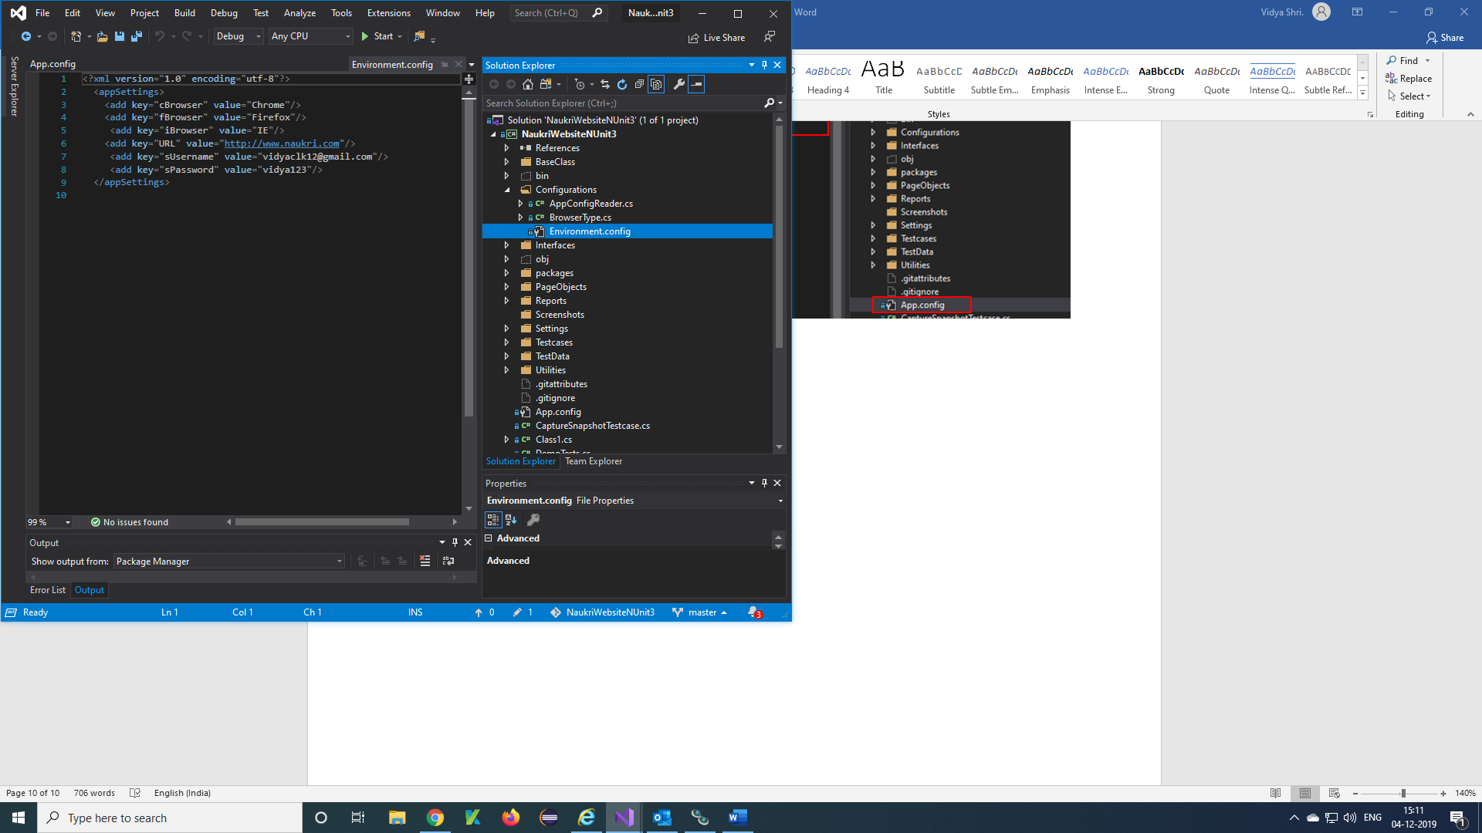

**Step 3)**Write a Data in Environment.config file

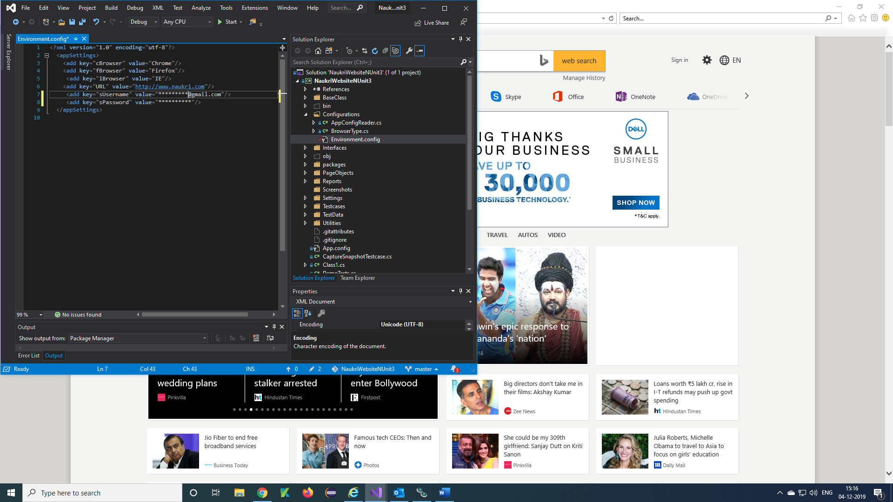

**Note:** Call the Environment.config file in App.config file

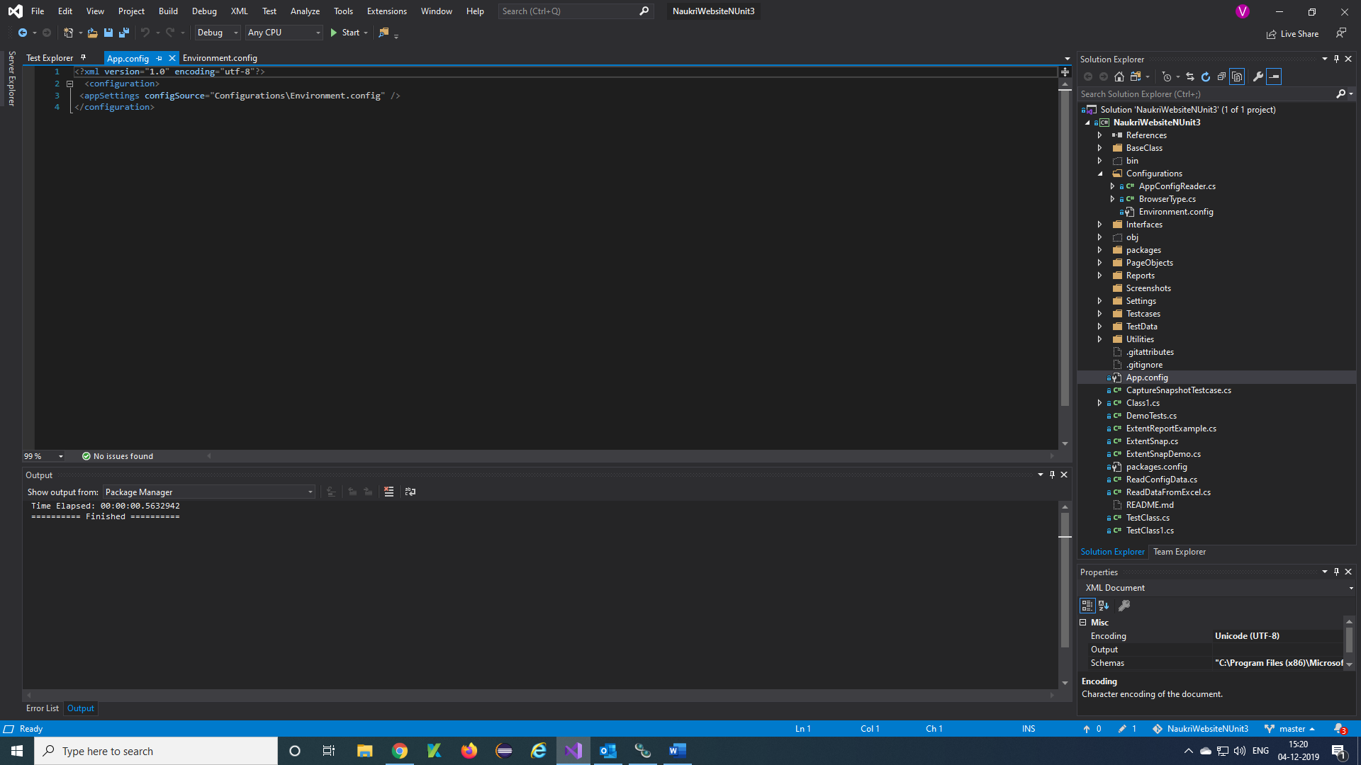

**Step 4)**Add Config assembly plugin to project

Right click Project solution 🡪 Add 🡪 reference

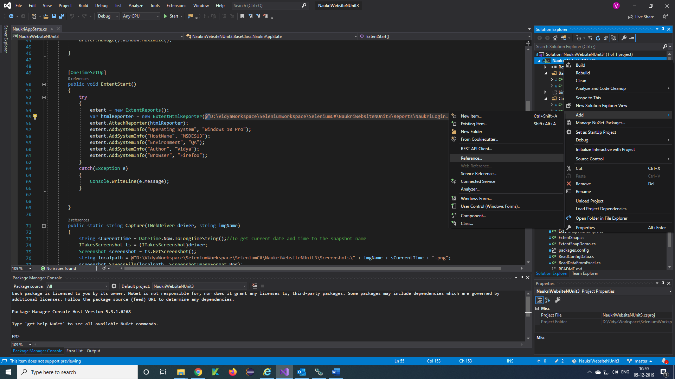

**Step 5)**Reference Manager window will appear

Click on Assemblies 🡪 Search config 🡪 Select

System.Configuration and System.Configuration. Install 🡪 Ok

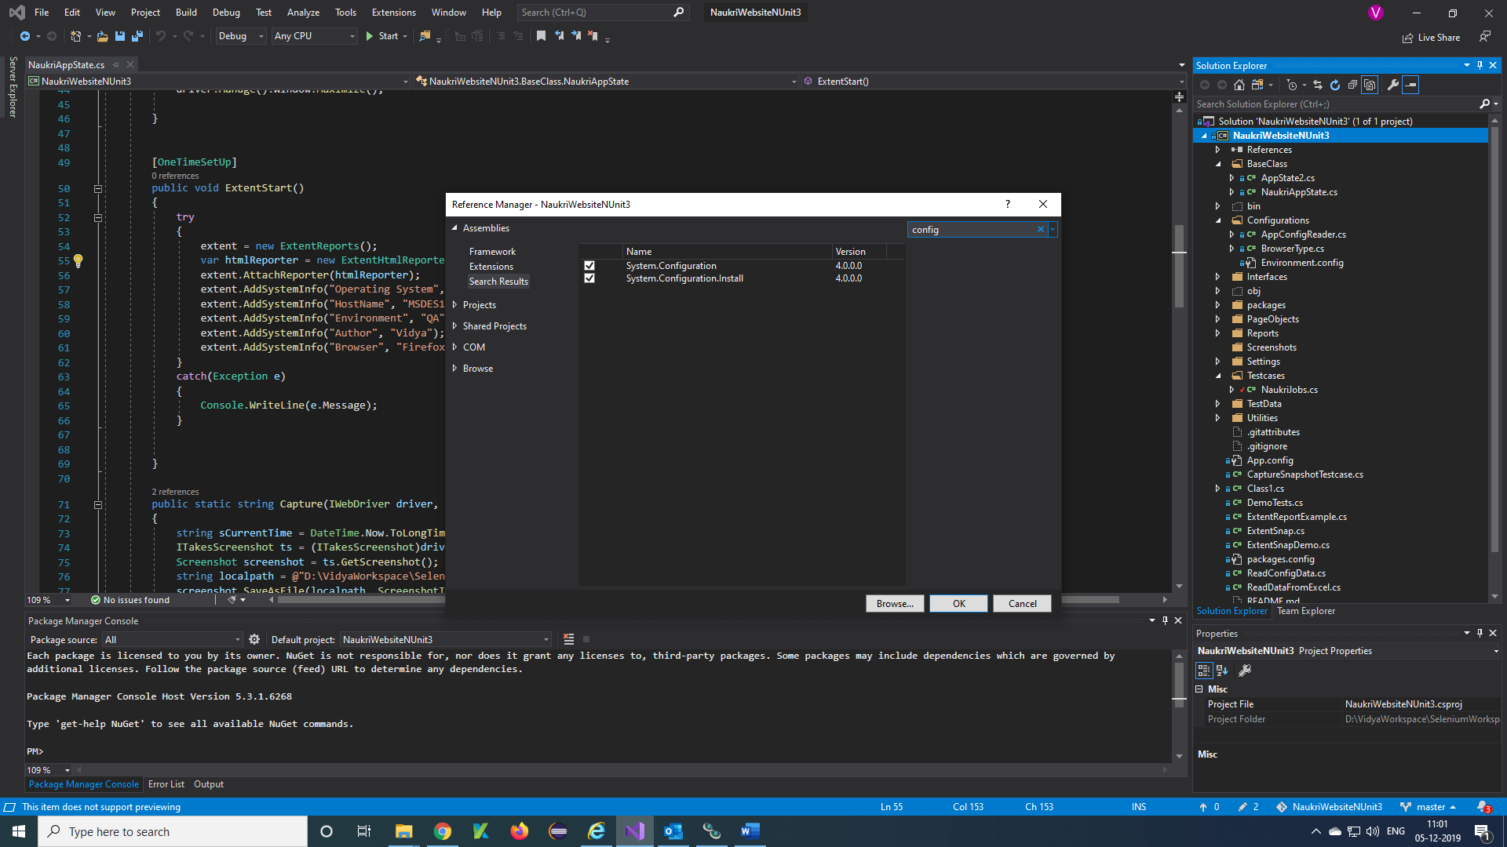

**Step 6)**Call the config data in the testcase

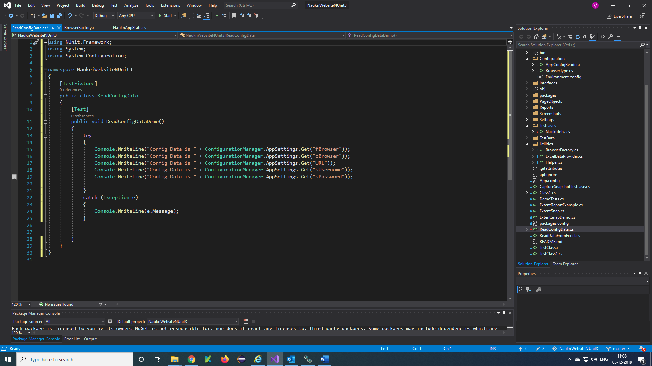

***Create Testcase:***

**Step 1)**Create a Testcases folder

Right click on project solution 🡪 Add 🡪 New Folder 🡪 Enter name

**Step 2)**Create a Class for your Test

Right click on project solution 🡪 Add 🡪 Class 🡪 Enter name 🡪 Add

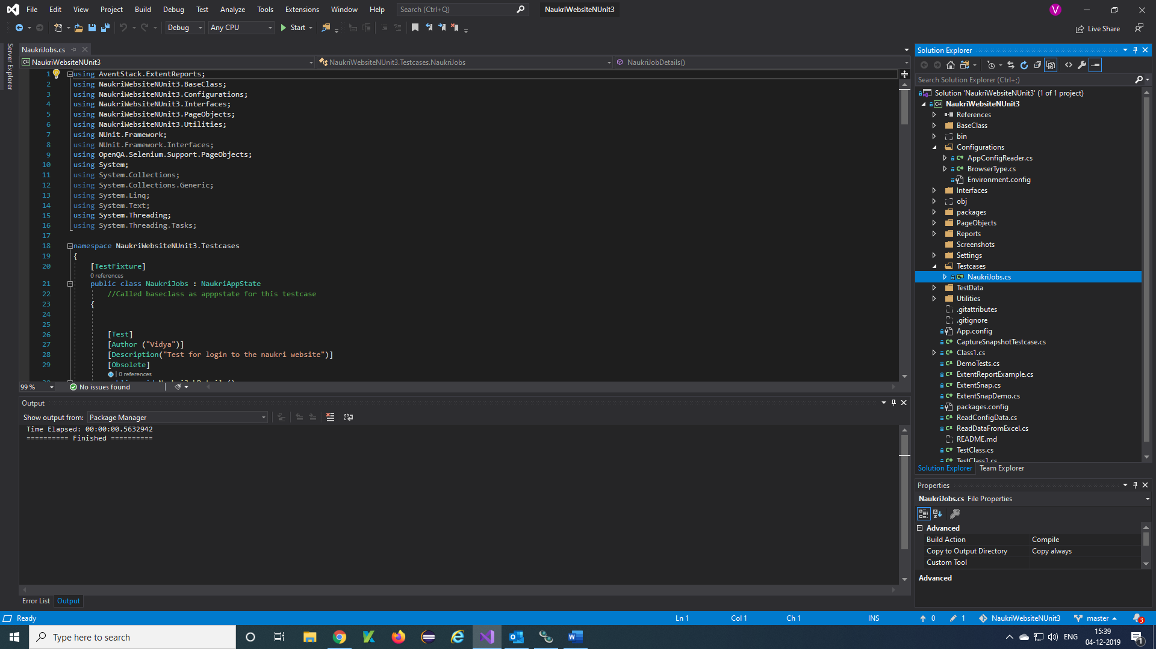c

**Step 3)**Write a function using annotations of NUnit framework

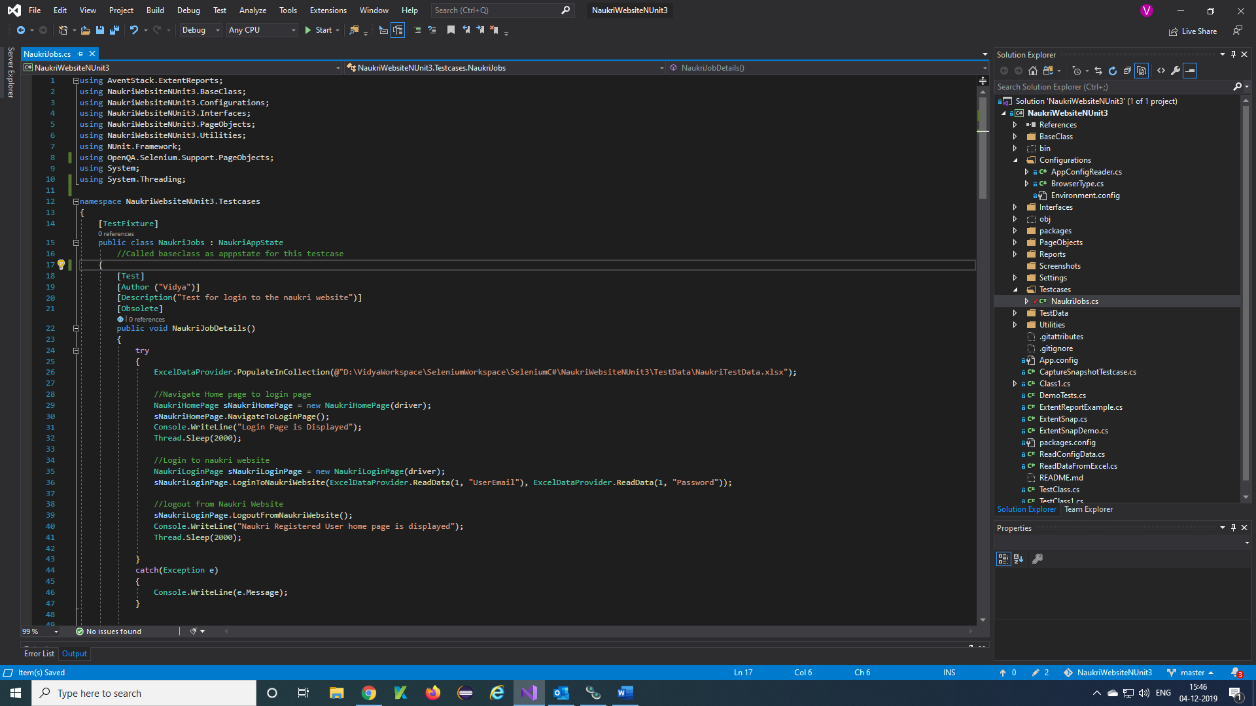

Getting Data from Excel

Import from plugins

Methods are calling from PageObjects

Annotations of NUnit

Called AppState foe OnStart and OnFinish

Build the Test and run the testcase. We can create multiple Test in one class, those multiple Tests are called Plan in C# selenium.

***Create Test Data & Fetching Excel values to Testcase:***

**Step 1)**Create a TestData folder

Right click on project solution 🡪 Add 🡪 New Folder 🡪 Enter name

**Step 2)**Create an Excel sheet for your testcase and add that excel sheet to TestData folder

Right click on TestData folder 🡪 Add 🡪 Existing Item

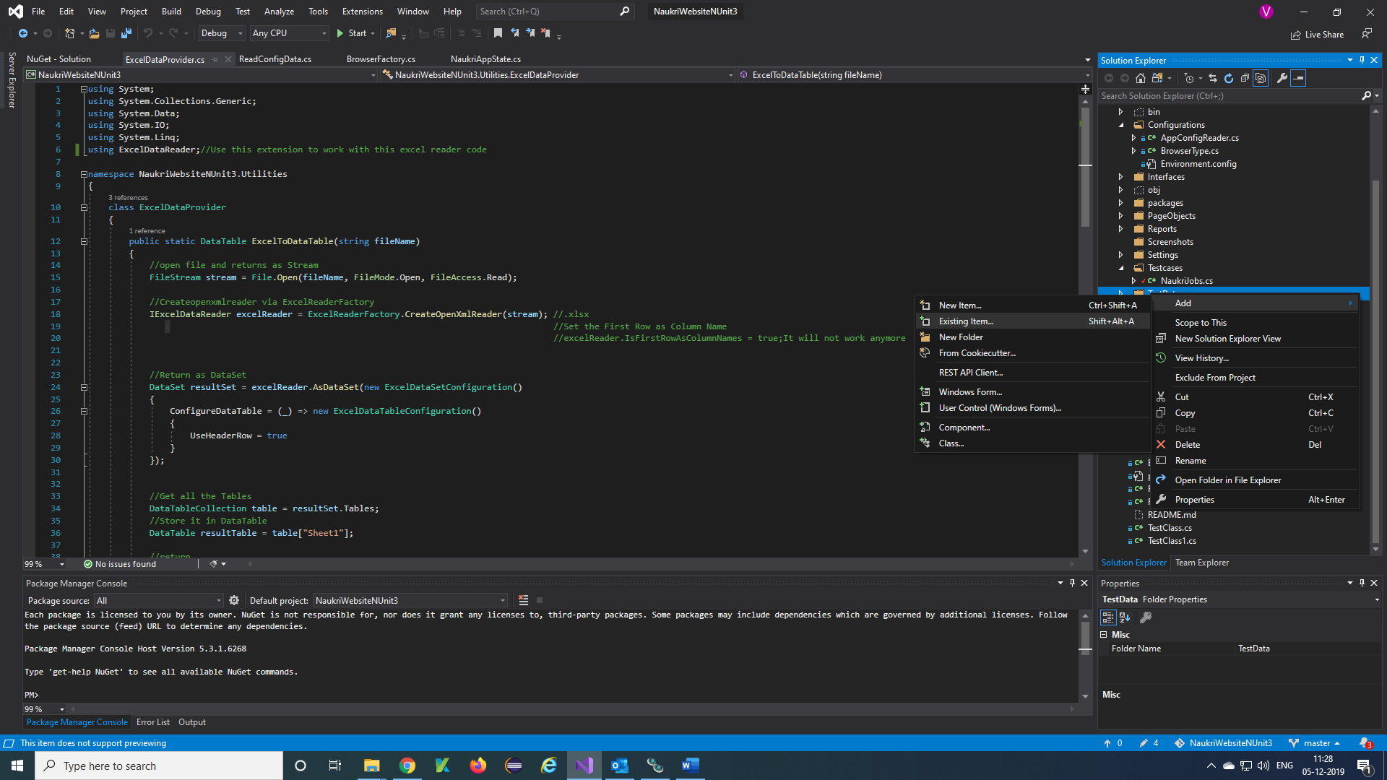

**Step 3)**File explorer will display, select Excel file 🡪 Add

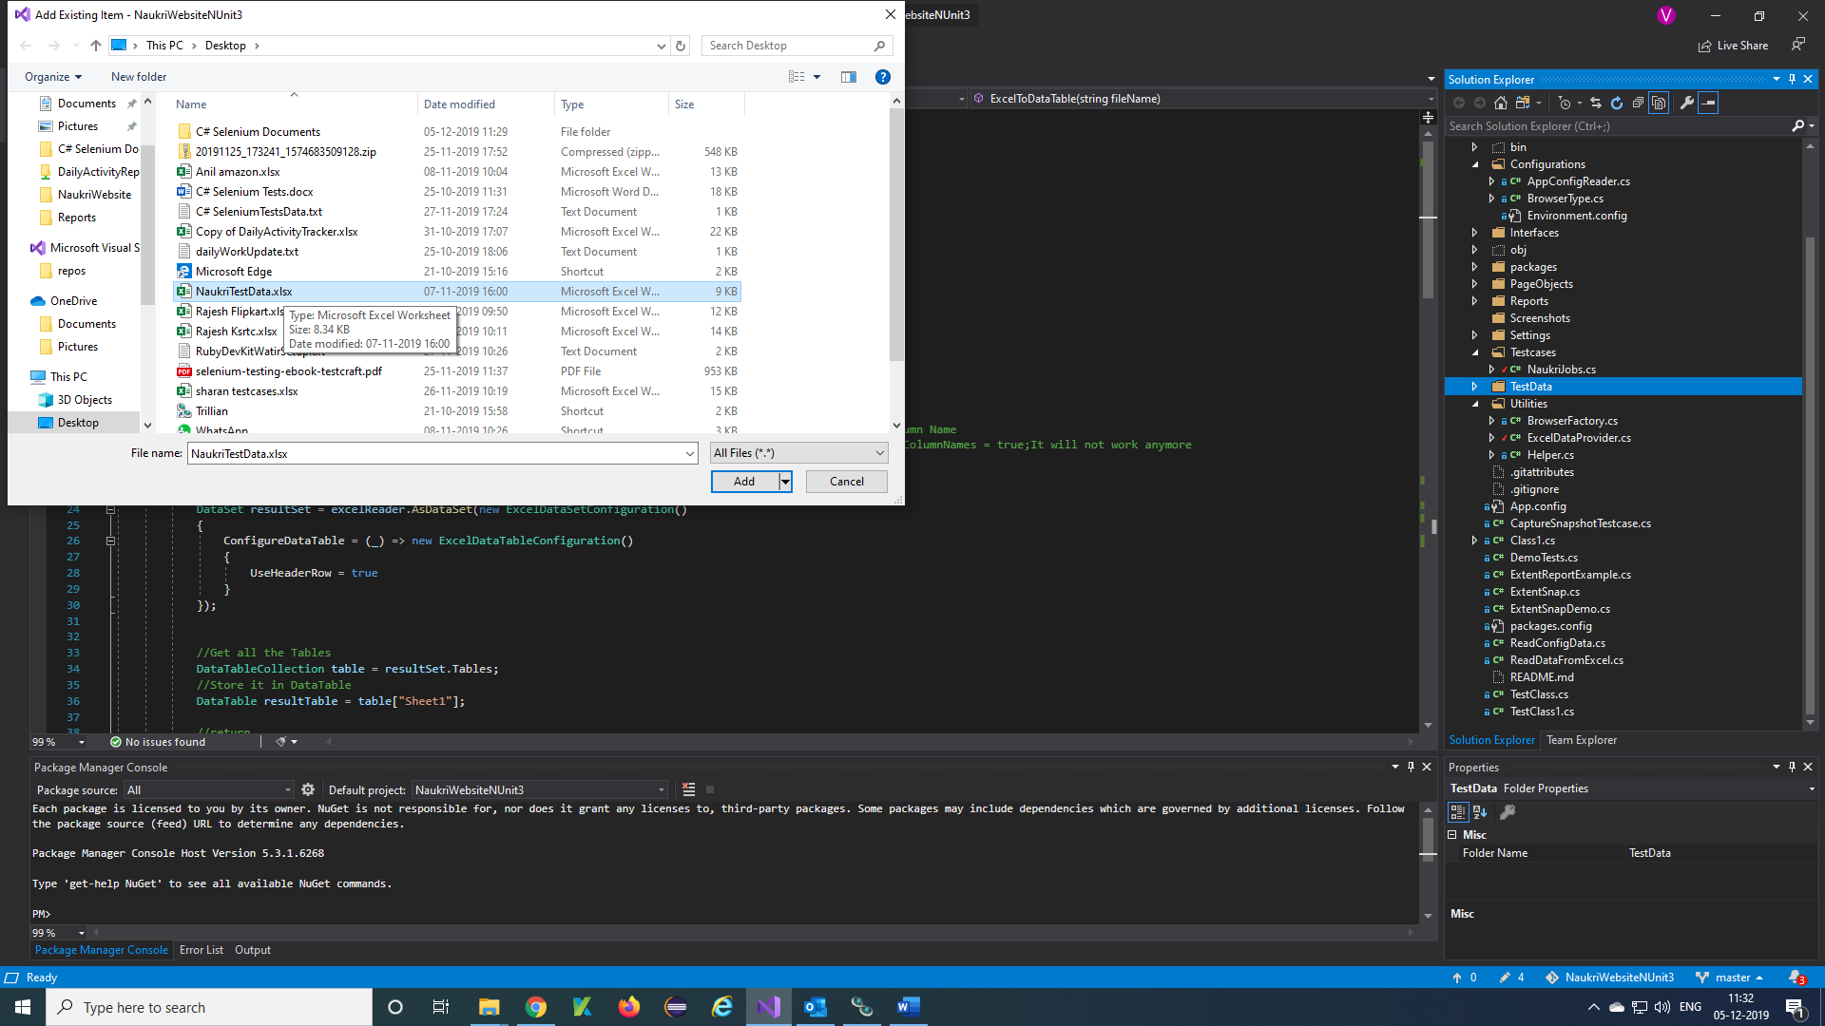

**Step 4)**Your Excel file will be added to your TestData folder

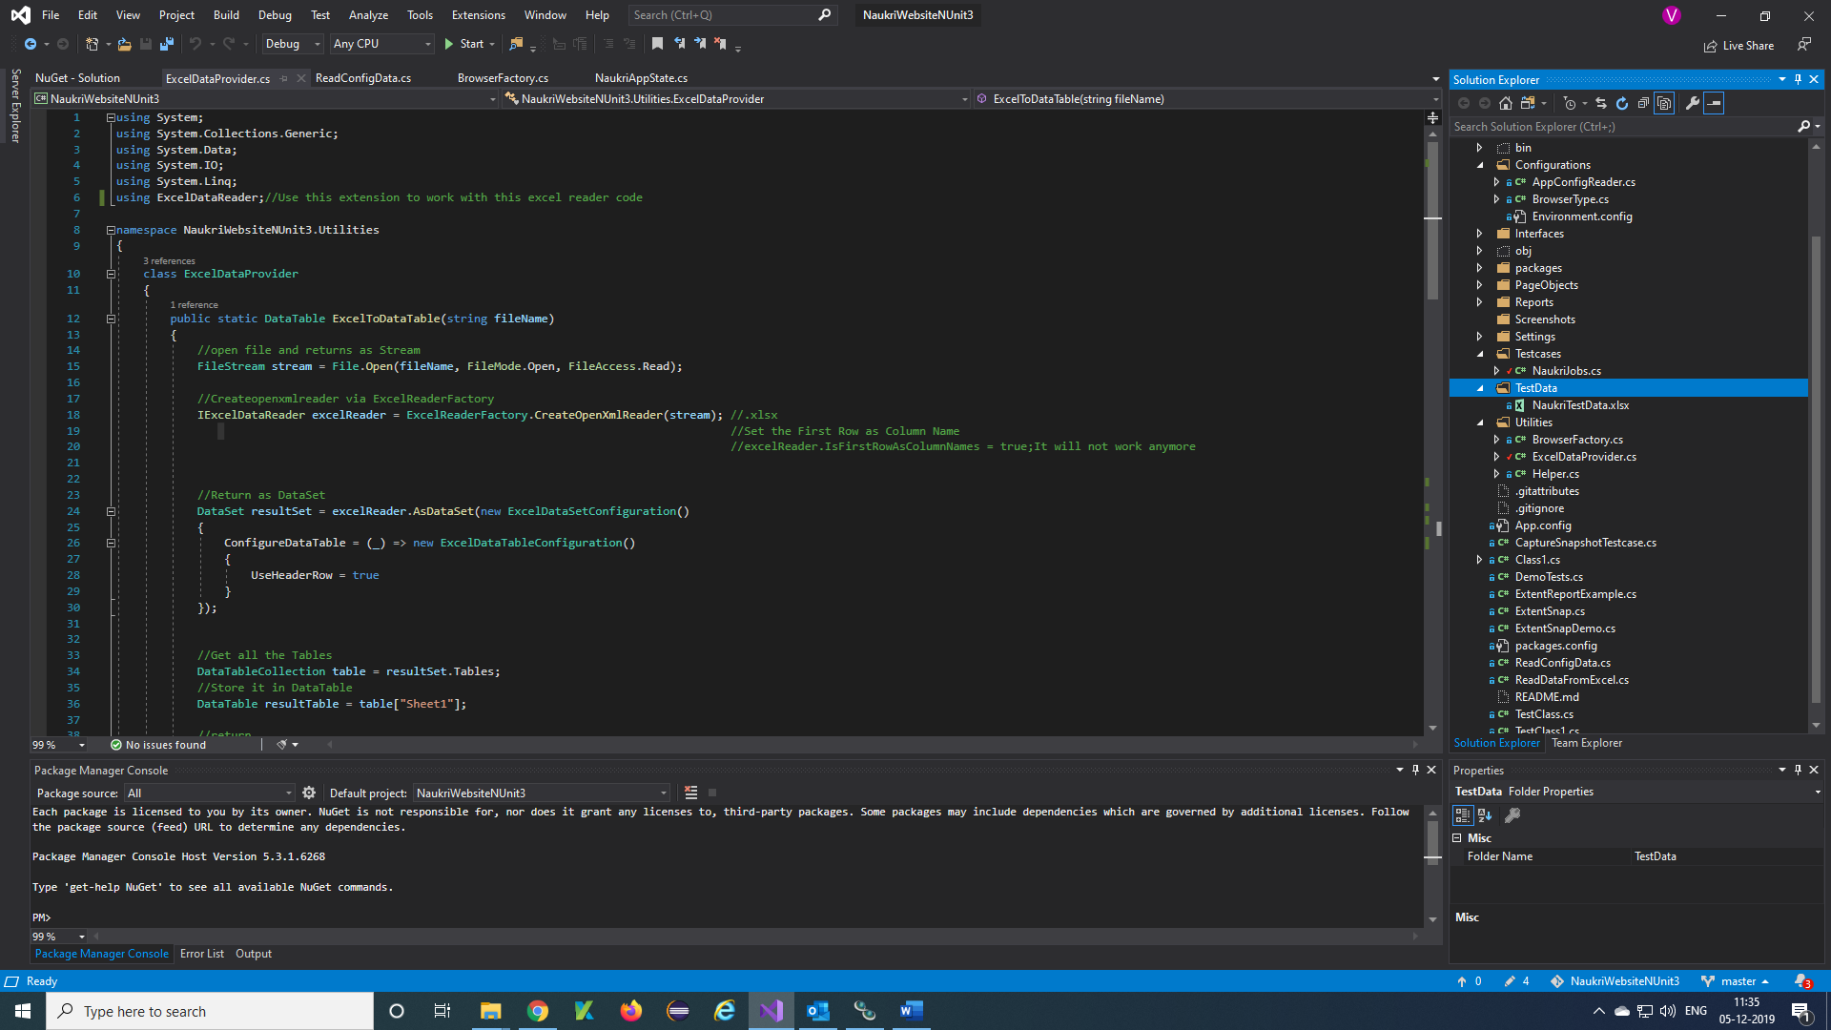

**Step 5)**Download and install ExcelDataReader plugins to project to create extent report for testcases Click on Tools 🡪 NuGet Package Manager 🡪 Manage NuGet Package for Solution 🡪 search excel 🡪 Install

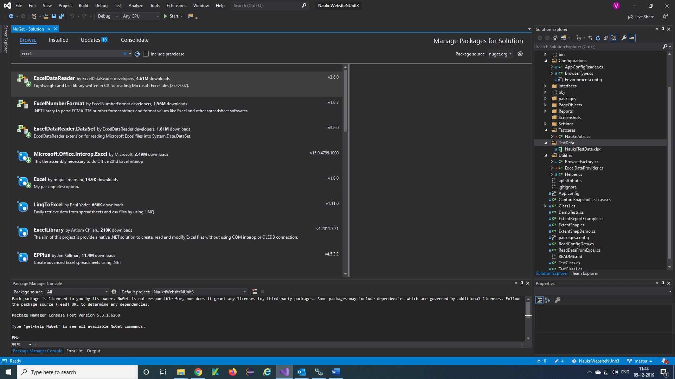

**Step 6)**Create a class in Utilities folder as ExcelDataProvider

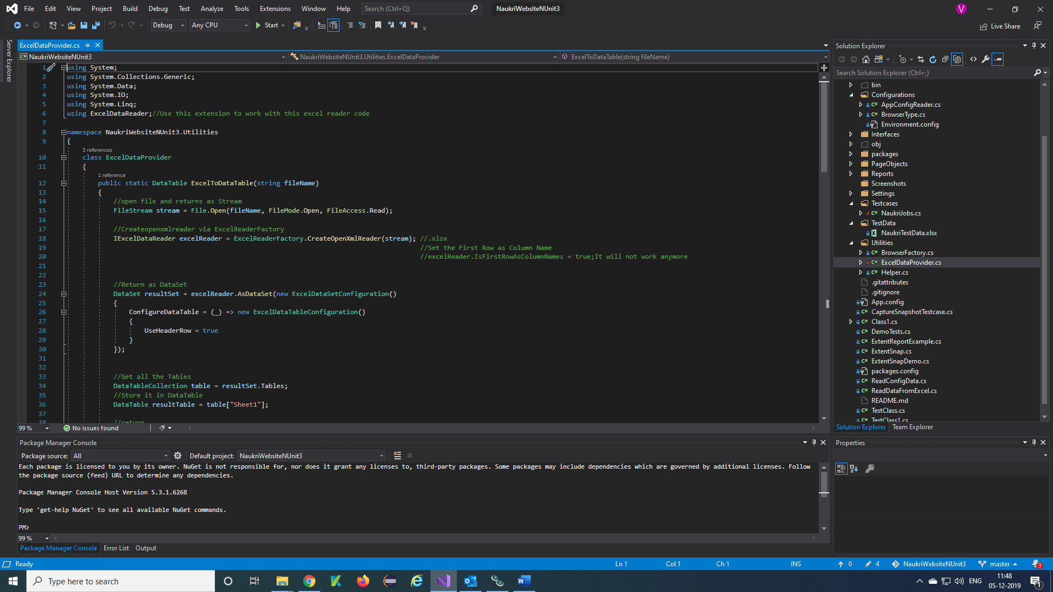

**Step 7)**Write a Function to fetch the values from Excel sheet

using System;

using System.Collections.Generic;

using System.Data;

using System.IO;

using System.Linq;

using ExcelDataReader;//Use this plugin to work with this excel reader code

namespace NaukriWebsiteNUnit3.Utilities

{

class ExcelDataProvider

{

public static DataTable ExcelToDataTable(string fileName)

{

//open file and returns as Stream

FileStream stream = File.Open(fileName, FileMode.Open, FileAccess.Read);

//Createopenxmlreader via ExcelReaderFactory

IExcelDataReader excelReader = ExcelReaderFactory.CreateOpenXmlReader(stream); //.xlsx

//Set the First Row as Column Name

//Return as DataSet

DataSet resultSet = excelReader.AsDataSet(new ExcelDataSetConfiguration()

{

ConfigureDataTable = (_) => new ExcelDataTableConfiguration()

{

UseHeaderRow = true

}

});

//Get all the Tables

DataTableCollection table = resultSet.Tables;

//Store it in DataTable

DataTable resultTable = table["Sheet1"];

//return

return resultTable;

}

public static List<DataCollection> dataCol = new List<DataCollection>();

public static void PopulateInCollection(string fileName)

{

DataTable table = ExcelToDataTable(fileName);

for (int row = 1; row <= table.Rows.Count; row++)

{

for (int col = 0; col < table.Columns.Count; col++)

{ DataCollection dtTable = new DataCollection()

{ rowNumber = row,

colName = table.Columns[col].ColumnName,

colVal = table.Rows[row - 1][col].ToString()

};

//Add all the details for each row

dataCol.Add(dtTable);

}

}

}

public static string ReadData(int rowNumber, string columnName)

{

try

{ //Retrieving Data using LINQ to reduce much of interactions

string data = (from colData in dataCol

where colData.colName == columnName && colData.rowNumber == rowNumber

select colData.colVal).SingleOrDefault();

return data.ToString();

}

catch (Exception e)

{ Console.WriteLine(e.Message);

return null;

}

}

public class DataCollection

{ public int rowNumber { get; set; }

public string colName { get; set; }

public string colVal { get; set; }

}

}

}

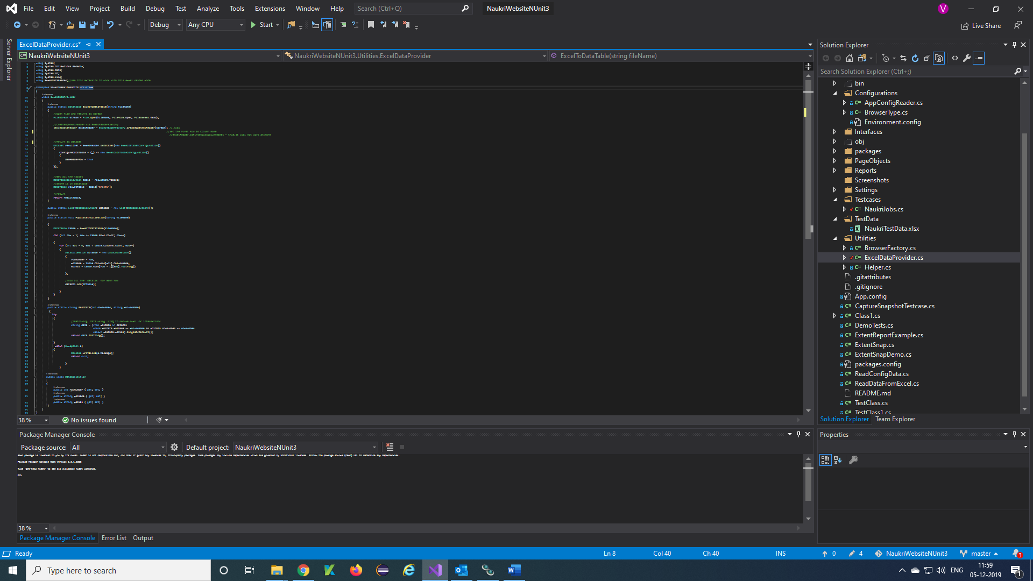

**Step 8)**Call ExcelDataProvider Function in the testcase

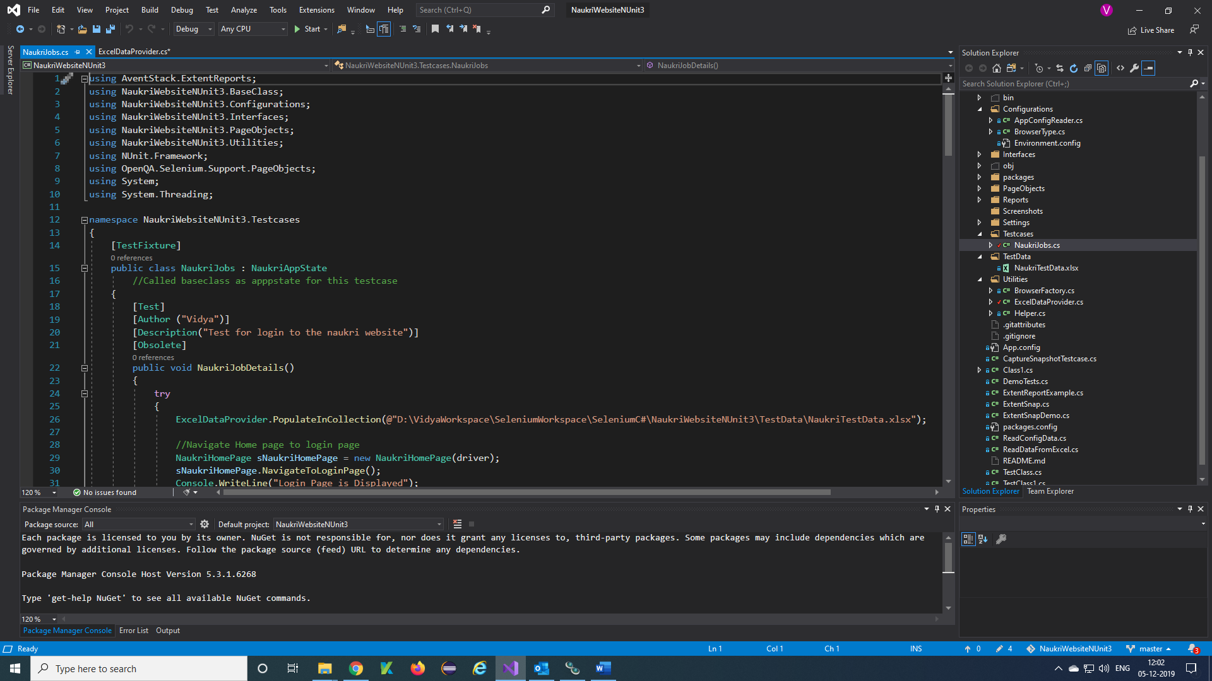

***Sending mail through program:***

**Step 1)**Write a program to send mail in AppState in your project

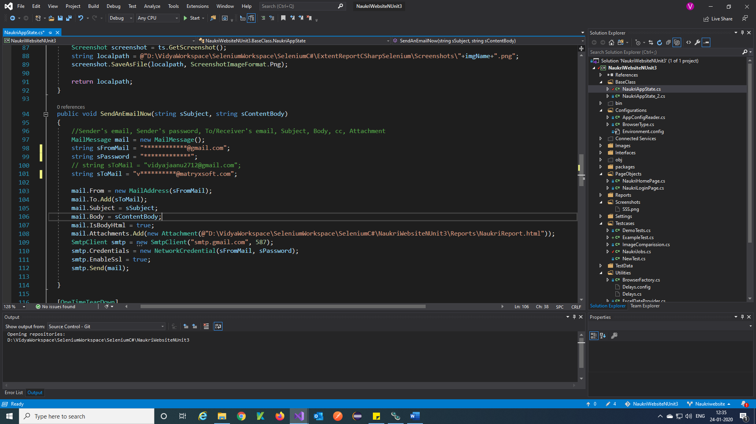

**Step 2)**Call SendAnEmailNow method in OneTimeTearDown of NUnit attribute in your AppState

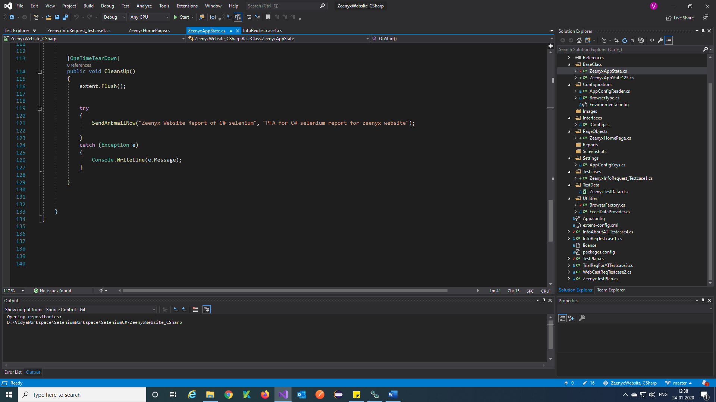

***Extent Report for C# Selenium:***

**Step 1)**Download and install Extent plugins to project to create extent report for testcases Click on Tools 🡪 NuGet Package Manager 🡪 Manage NuGet Package for Solution 🡪 search Extent 🡪 Install

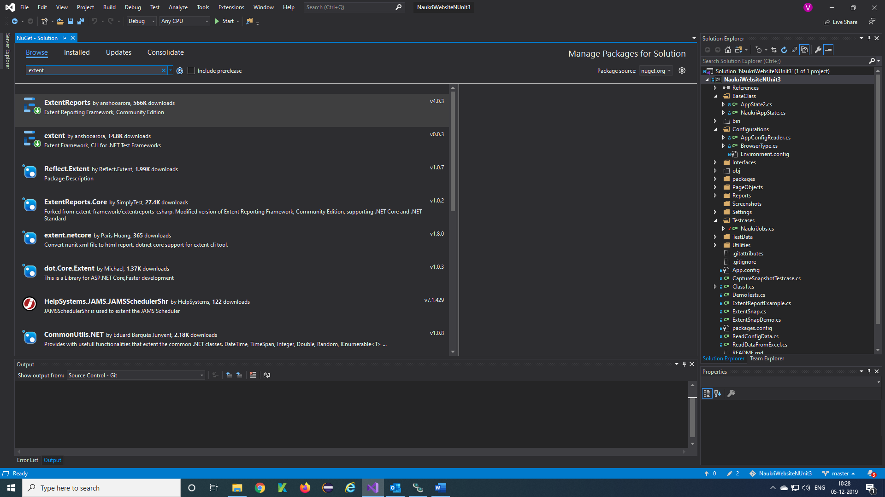

**Step 2)**Create a Reports folder in project

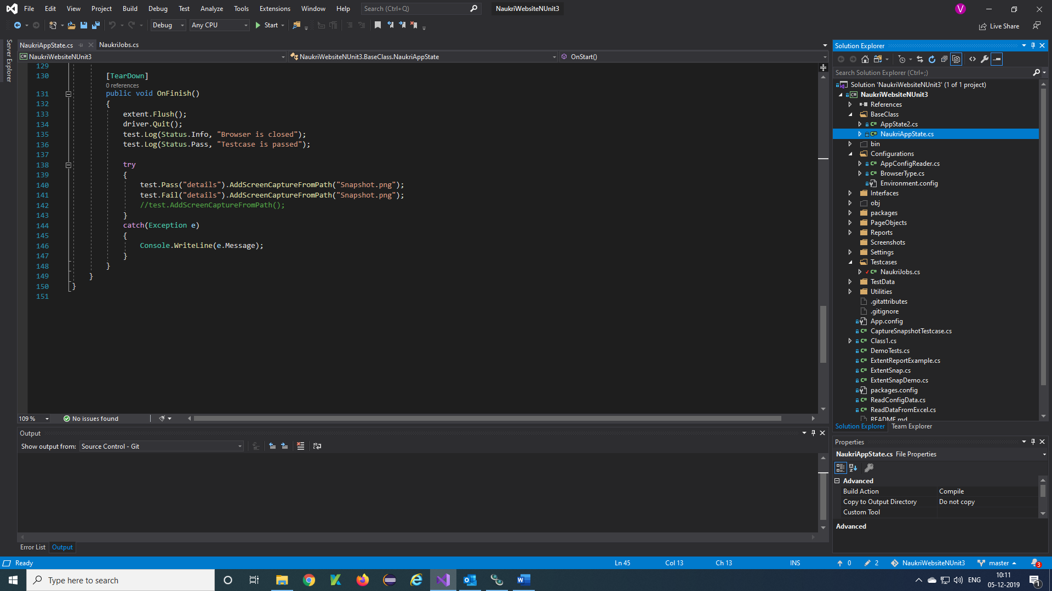

**Step 3)**Write a function to extent report in AppState using OneTimeSetUp annotations in NUnit

Give the path of the report folder to save the testcase reports in that folder 🡪

@"D:\VidyaWorkspace\SeleniumWorkspace\SeleniumC#\NaukriWebsiteNUnit3\Reports\NaukriLogin.html"

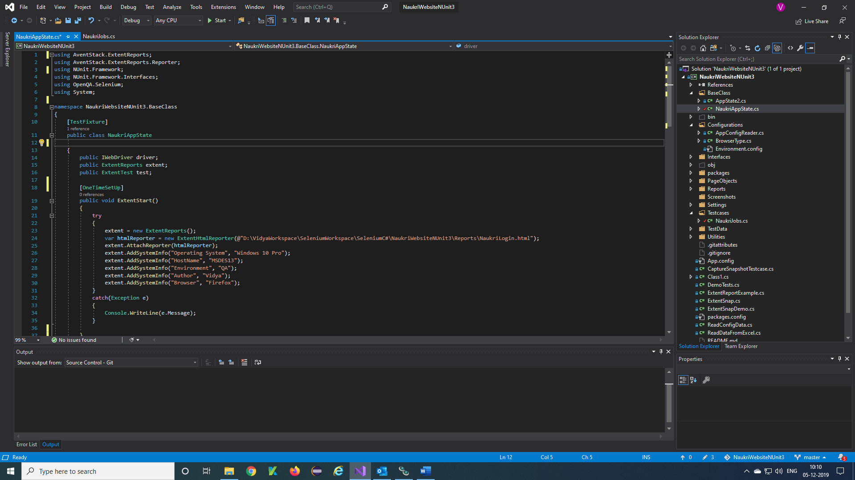

**Step 4)**Close the Extent report after report is done use TearDown Annotation

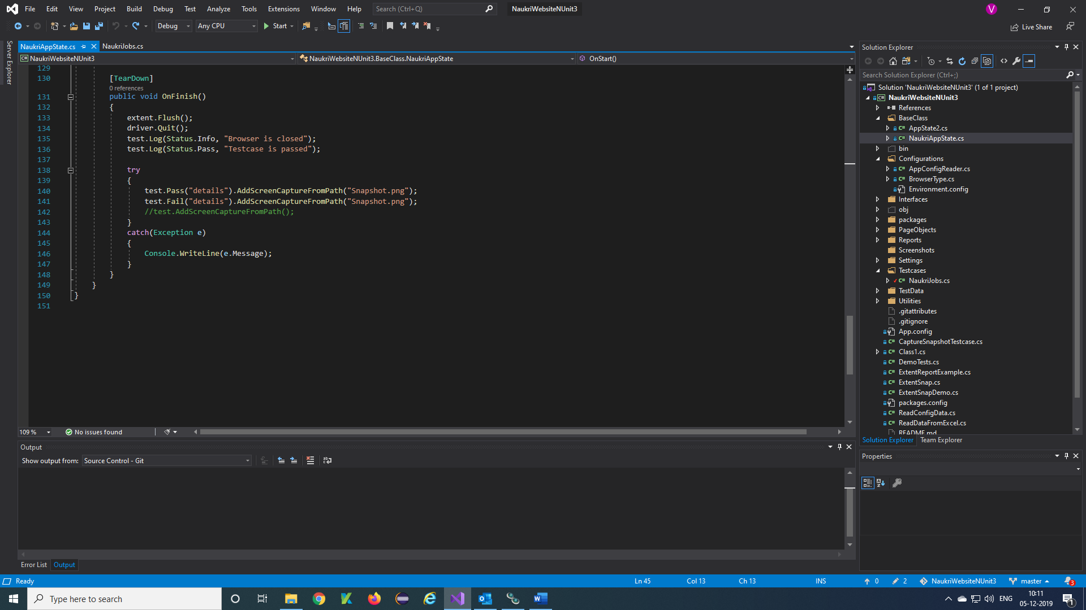

**Step 5)**To check the report of the testcases

Right click on Reports folder 🡪 Open Folder in File Explorer

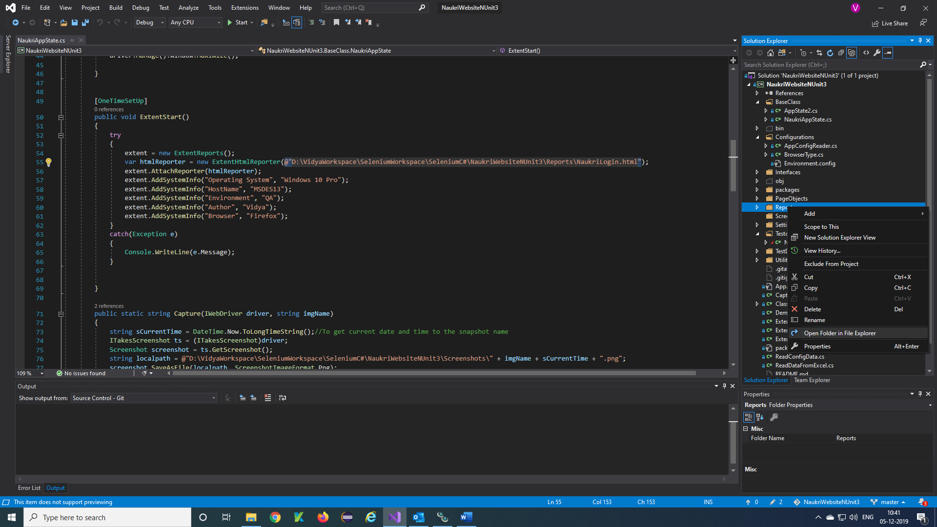

**Step 6)**Reports File will be display, Double click on reports and open

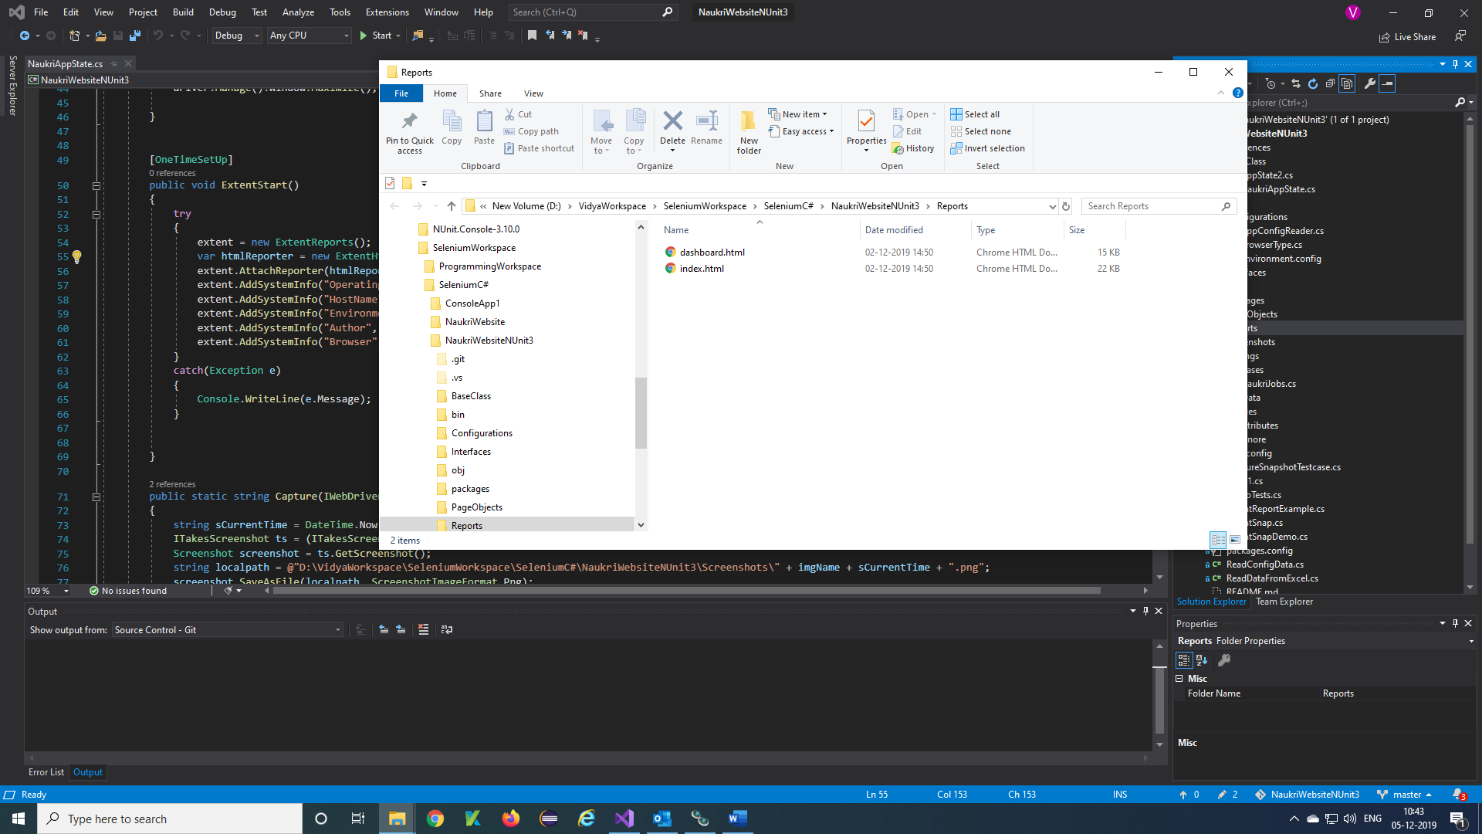

**Step 7)**You will get reports like this

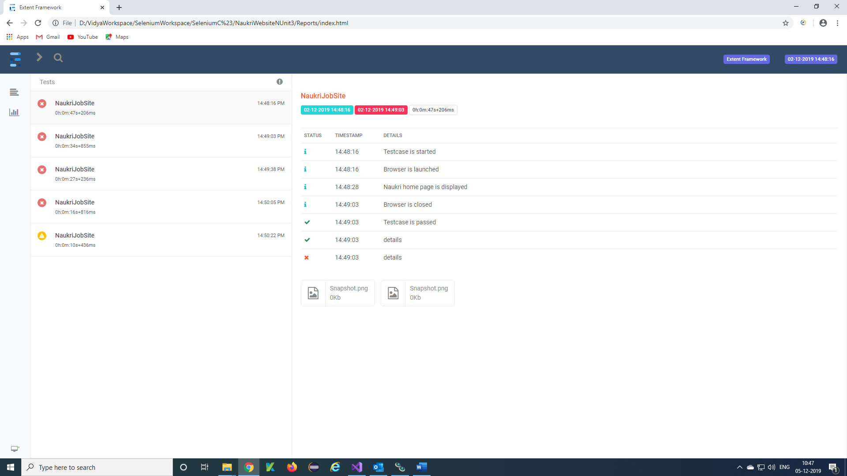

Piechart report of the testcases.

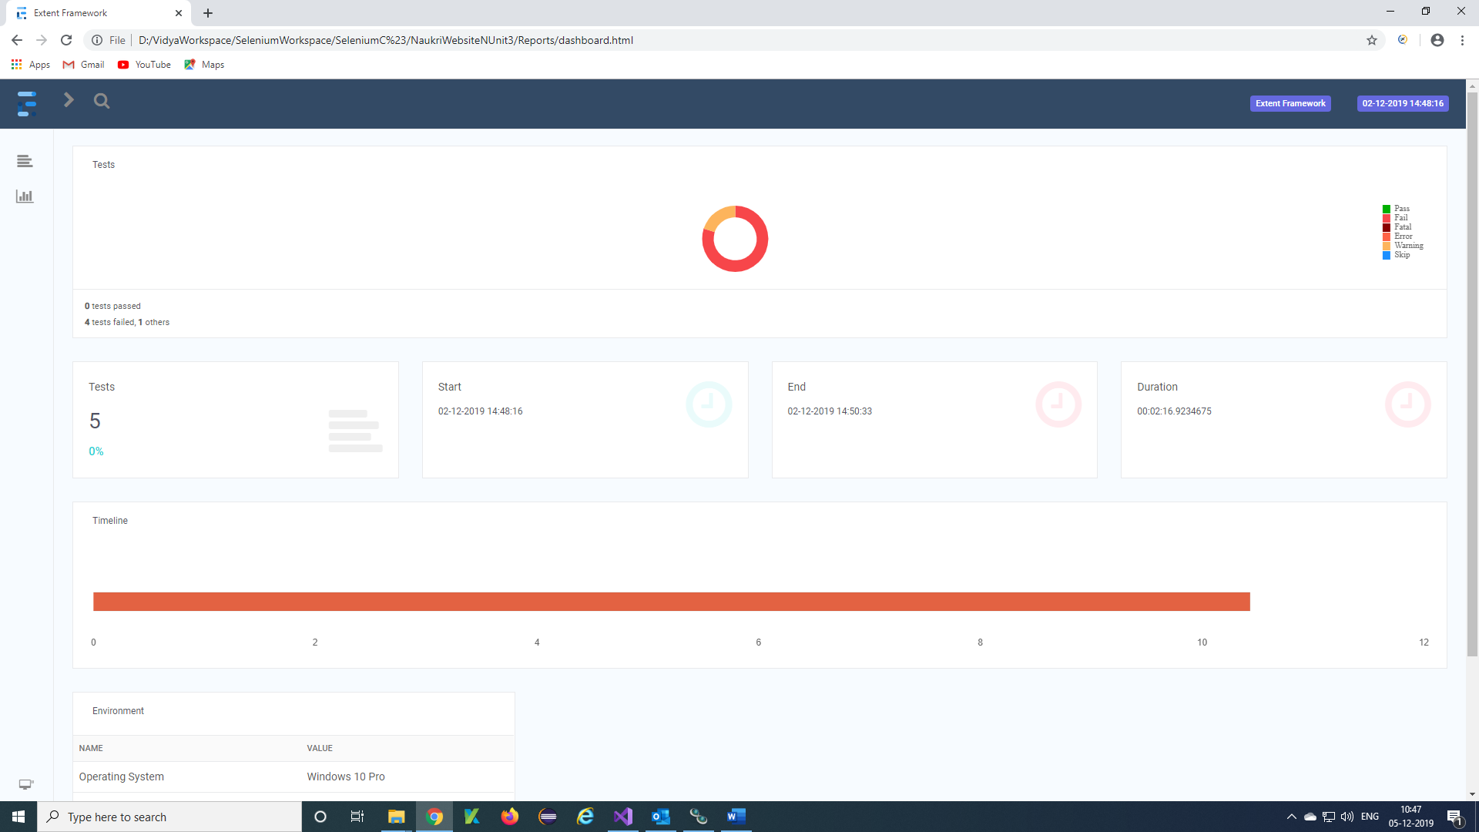

Details of testcase, PC, Author of testcase ..

